SMAC CES Committee
Meeting Minutes
08/06/2020
Attendance (per the Chat Box): Heather Duchscherer, Hearth Connection; Dana Dumbacher, Washington County; Matt Lewis, RADIAS Health; Sheena Addis, The Link; Hope Inman, Salvation Army Anoka; Natalie Engelmann, Anoka County; Kristen Brown, Matrix Housing Services; Plavina Chiado, CAP Agency Shakopee Mn. Filling in for Suzie today; Sue Rosendahl Salvation Army; Alyssa Paulson, Hearth; Teri Lazaretti, Dakota County Social Services; Linda Hall, Dakota County; Michele Reid, Anoka County

SMAC CES Committee Co-Chair spot open! Please reach out to Liz Moen and/or Michele Reid if you are interested!!

- COVID-19 Housing Assistance Program (CHAP) update
  - The Salvation Army worked as lead applicant for SMAC Region
    - Sub grantees including HousingLink and others available related to prioritization
    - Award Amount
      - To be announced in about a week, on or before August 10, 2020
    - MN Housing would like to “cut checks” to grantees Monday August 17, 2020
  - 3 sub-groups – opportunity to help share info
    - Marketing needs and information to be shared via email as things develop

- Assessor Training update
  - Evaluating how many assessors and how often should we be having assessors’ complete assessments?
    - Wanting to make sure that assessors are providing commitment service throughout the continuum
    - Wanting to make sure assessors can stay up to date with how to complete the assessment/trainings/changes
    - 86 Assessors, 44 have no assessments in priority pool currently
    - Reviewed Policies and Procedures
  - Results from online quizzes
  - How many assessments/year is too few?
  - Dig into data of how many assessors complete fewer than 1/month
  - Policy – what does it mean to be a trained assessor? Review.
  - Draft language including flexibility for supervisors/back-up/specialized
  - Should we wait to review this due to the current eviction moratorium and other housing concerns?
  - Proposal: Having language that says something similar, to:
Draft Language: There is a preference for, or an ideal that, CES assessors will complete an assessment once per month on average, in order to ensure that they are keeping up on their skills and knowledge related to HMIS and the CES assessment. At the annual recertification time, before recertification is complete, CES Staff will check-in with assessors who may be completing CES Assessments less than monthly, to explore whether they would like to continue to be a current CES Assessor.

- Advisory Update- Jen R.
  - 2020 Variance results – overall numbers
    - 47 requests received from July 2019- June 2020;
      - January-June 2020 21 requests; 12 approved
    - Types of variance requests
      - Change a person’s priority to update priority placement type
      - Transfer request
        - If requests are denied, often request for more information
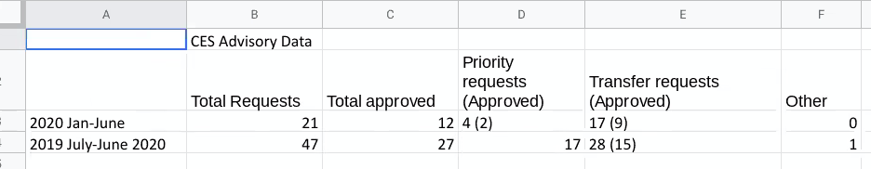
  - How often would reporting make sense? Goals around quarterly reporting related to variances
  - Please see variance request FAQ for further information
  - Requests: would be helpful to have information about requests and approvals for households moving from RRH to PSH
    - Helpful to have information separately about families and singles
    - Also please report back if the Advisory group is seeing patterns in requests that are concerning/encouraging

- Update on ending Veteran homelessness
  - Moving forward related to “functional zero” related to Veterans experiencing homelessness
  - Having ability to permanently house a veteran within 90 days or so of Veterans entering SMAC CES
    - Multiple Benchmarks to meet criteria
  - Still in process and will be reported on-going
  - Oh the way there! This is good news!

- CES Committee Feedback
  - Review surveys
    - Overall people like this meeting and the committee, and are finding value
    - How to increase participation with virtual meetings

- VI-SPDAT Version 3.0 – Statewide tool discussion
  - Providing feedback to the statewide workgroup
    - Options:
      - We are not interested in looking at any version of this tool
      - We would like to review this version and provide feedback to Liz/Abby via email
      - We would like more time to have a broader discussion about this tool at another time
    - Decision: SMAC CES is not interested in a VI-SPDAT form

Chat Box discussion points related to VI-SPDAT:
- The new version has very few differences from the old one. I do not see the value in using it at this time. That being said, I only glanced through it and may have missed changes that the state felt were important?
- As an assessor I feel it is a step backwards to a point system- we have spent lots of time educating the community to the new changes without points etc..
- Doing a CE assessment without any VISPDAT seems much more trauma informed. There are a lot of repetitive questions on the VISPDAT that I remember the Director's Council did not like
- If SMAC isn't going to use the VI-SPDAT as a tool of assessing priority than I don't feel it as being useful in the future. Also as an assessor who does anywhere from 1-6 assessments per week, I find the VI-SPDAT very problematic and not trauma informed or client strength based. Also, not using the VI-SPDAT saves a lot of time!
- Also, with the tool it seems we are just repeating the same questions over and over. We have a good Step 1 and 2 and we seem to be getting the data we need. The VISPDAT was not trauma informed and so hard on the people we assessed.
- I agree that I think removing the VI SPDAT is repetitive and don't think it's equitable either
- Not interested in new version regardless, for all reasons discussed; agree with conversation. OK with feedback!

- Review actions/next meeting
Next meeting September 3, 2020 9:00am-10:30am via Zoom
Liz to type up proposal regarding Assessor amounts and

