SMAC Governing Board Agenda
  - May 21, 2021
  - 1:00-3:00
Conference Call Option: 1-312-626-6799 Meeting ID: 996 1800 6407
Zoom Link: https://zoom.us/j/99618006407

- Introductions/Board member spotlight 10 minutes
Heather D Hearth Connection, Corey Samuels, Guild, Michele, Jenny Mason, Abby, Jaime, Rochelle, Liz, Kelina, Tonya, Carla Doreen, Kesha, Betty , Rukhsana, Kamara, Jen R, Dan LS, Eric Gentry, Ann Lindquist, Paul, Rebecca, 763-221-6564,
- Approve March and April minutes *Vote Required 5 minutes
Moved by Carla, Second by Tonya – passed unanimously; no opposed.

- Small Large group work 30 minutes
  - Guiding principles for work together as a board
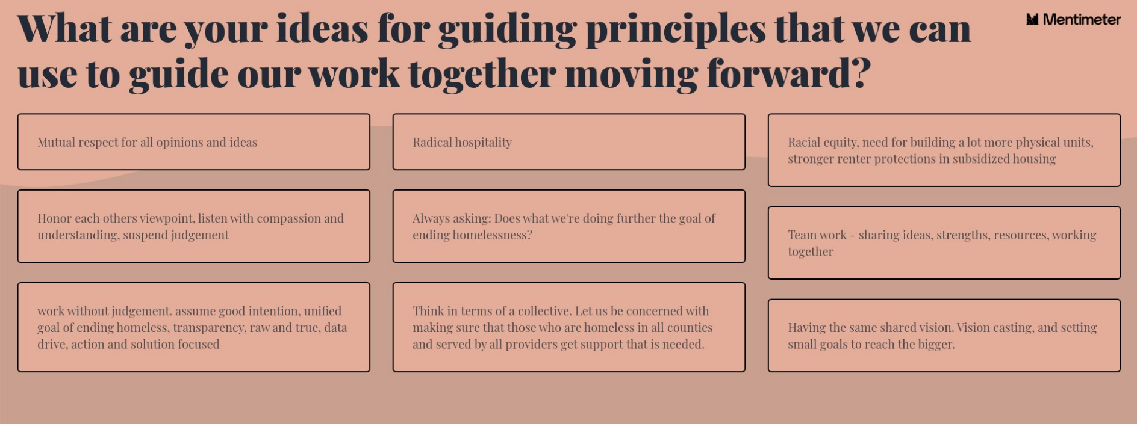
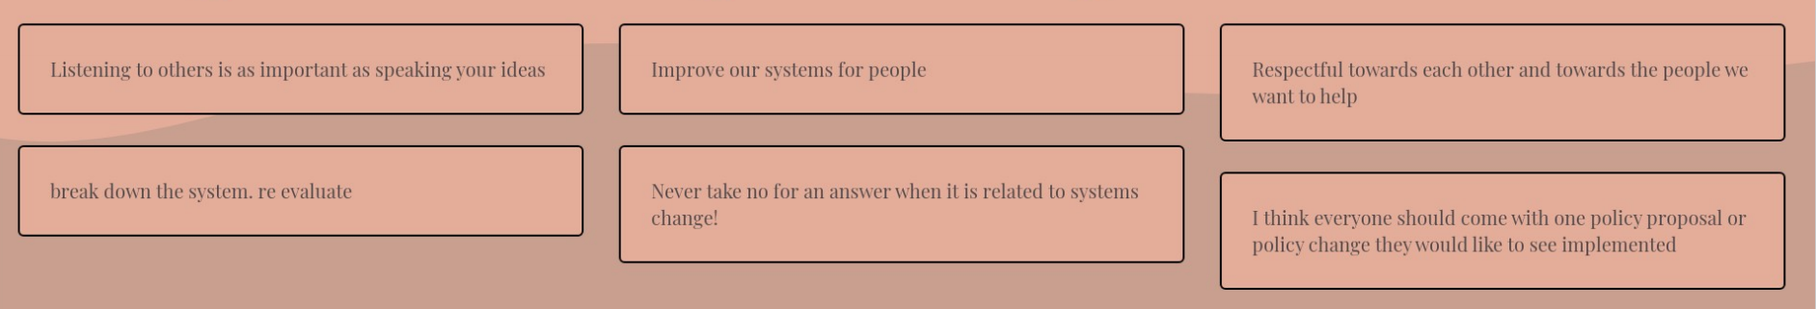
  - Input on meaningful meeting structure
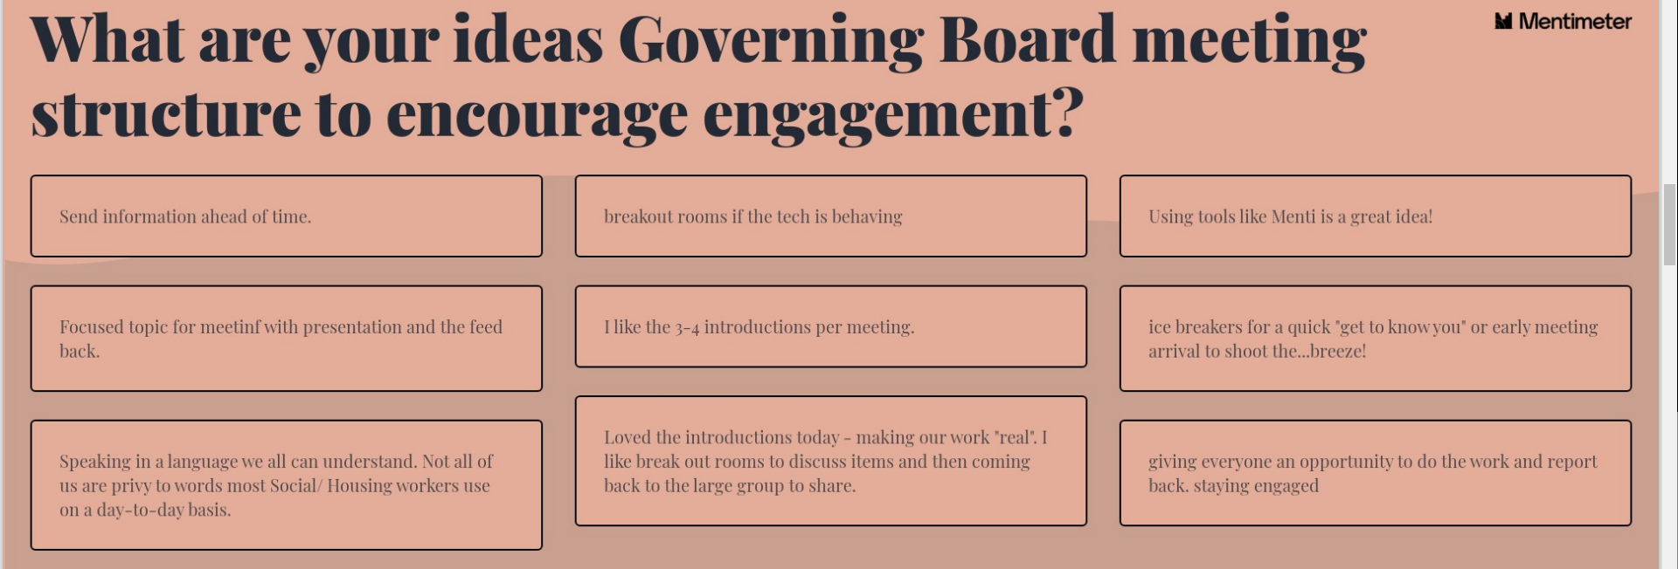
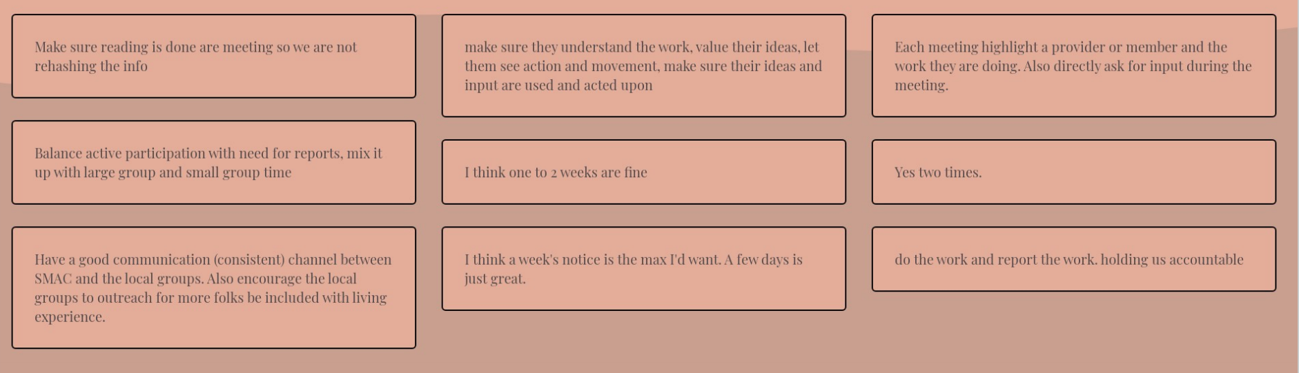
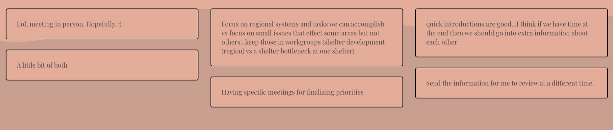
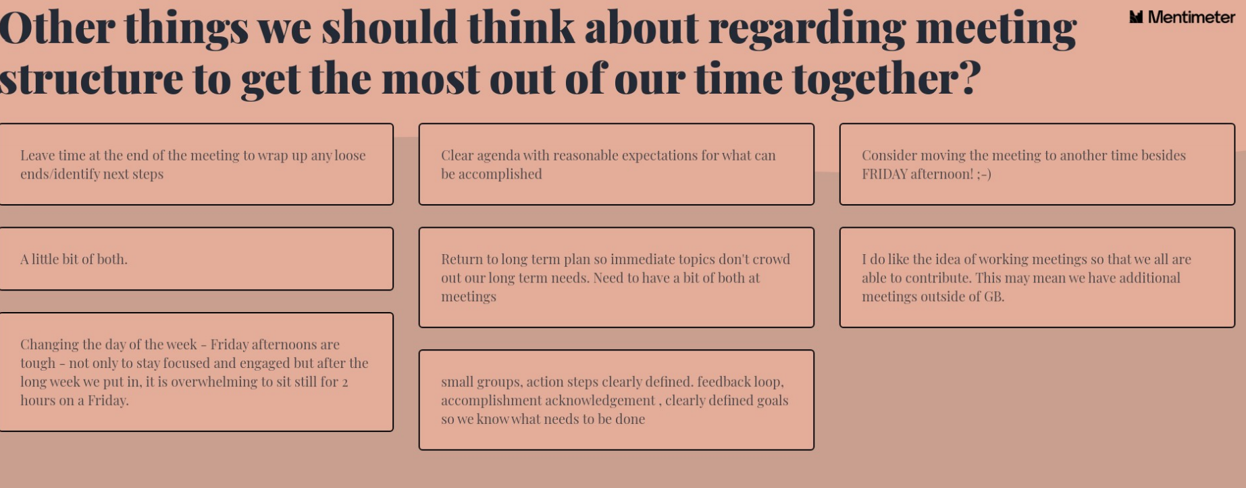
  - Continued discussion on 2021 priorities
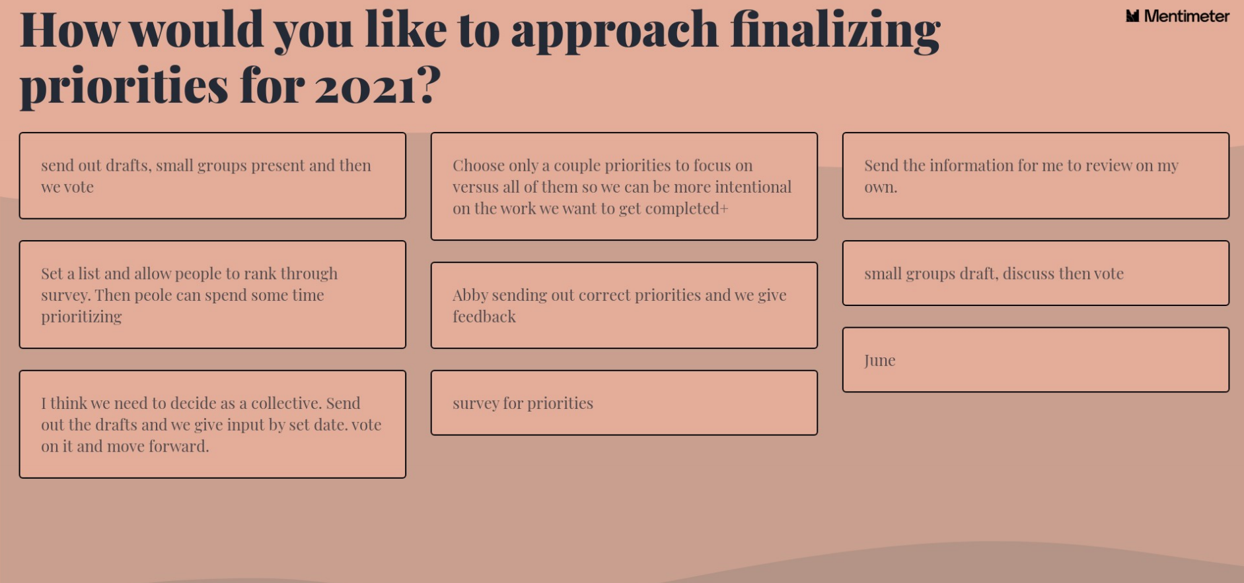

- Setting guiding principles -Menti.com 2885 8118 10 minutes

Finalize priorities – how to do this? Large group discussion, Abby to finalize plan, have Exec Committee work it out…other thoughts?

Vote on in June. Housing projects for June as well. Consent agenda and review. Will be recommended from local areas. Make sure people read it ahead of time – GB members agreed.

- Coordinated Entry Overview 20 minutes
  - Connection to Governing Board
  - Centralized Access work group
CE Committee meeting 6/3 at 9am via zoom! Email Liz to get invited!!
Goal for CE is to ensure anyone who needs access to housing has access to housing. Currently we don’t have enough resources for the people who are on the list and service they need.
CE committee is trying to be as trauma-informed, person-centered and as informed as possible.
Will talk broadly where we were, what we’ve done and where we are going!!! Join us in June.
Confusing across the CoC’s. Understanding SMAC requires a bit more of a nuanced conversation. Come join us!!! June meeting overview, then data after.

- Program Eligibility Review and Approval *Vote Required 20 minutes

Liz walked through excel document on program eligibility updates. Check email for GB attachments.
Kelina moved to approve language and added to SMAC website – Carla Second, voted unanimously, no opposed.

UPDATE to review updates - Monitoring and Evaluation Committee will get into weeds and bring back the next steps to GB -
- Eligibility concerns from CES Committee – Liz shared status and gave CES committee feedback.
- Canvas project – require a CH Dx. Doesn’t pull in PL for CES. Only program with that criteria, only a couple at any time that fall into that. NO need to comb through all the people in PL. Does funding require that? Paired service requirement but not of funding.
- Dakota

Do we need to set scoring criteria? Who’s a part of it? Need to recruit more? Review applications in Director’s Council? 3-4 more applications. They are coming in slowly.
Work for or are receiving $$ from COC, then Conflict of interest. For any member/attendee.
Policy and Procedure documents will need to be approved during the June meeting. Needs to be done before NOFA drops.

- Review of Point in Time and Housing Inventory Chart data 10 minutes

If ?’s and want to see more, no racial data, can get it. Just submitted in the last couple weeks.
** typically a sheltered count – ES or TH or people who are unsheltered – outreach teams and volunteers. HUD allowed us to waive the unsheltered count in 2021. We expanded sheltered and PIT went up w/out unsheltered count. 2020 – 561, to 2021 – 610 overall totals.

Abby to send as well, ask ?’s if any.
Veteran Registry is 17, can’t say they are the same and the fact they are close is good for the region.

Why is there a variation in DV? b/c more shelter capacity, a joint project that served all COC’s and stayed in Dakota, that number could explain why things went up. All were counted in PIT and HIC.
Are % the same from year-to-year?

Abby to pull it apart. Not enough shelter beds.
Rebecca – were knew of people who went to hotel vs congregate shelter setting Dakota doubled capacity b/c of it.
HIC

- All that serves people experiencing homelessness. IN and OUT of HMIS.
- Emergency Shelter bed went up by almost 130, BIG DEAL, we’ll see if it’s sustained or not.
- Transitional Housing – went up a bit. No beds added a recategorizing
- Rapid ReHousing – no utilization, requires a 100% match.
- Permanent Supportive Housing – housing requires a disability in eligibility – some re-categorized
- Other Permanent Housing – this increased through MN Housing tax credit
- Emergency Housing Vouchers – how will this be prioritized for DV?
  - Abby to connect with Sneha to ensure DV households are served.
- All numbers from PIT/HIC goes to congress to set amount available for federal funding.

Emergency Housing Vouchers – HUD
Emergency Rescue Act – HUD awarded these -PHA’s Dakota CDA -50 Metro HRA, Anoka/Carver – 281
What’s unique about these vouchers PHA is required to take referrals from CE. COC needs to enter into a MOU with Public Housing Authority, that outlines prioritization, on-going services, referral strategies. Needs to be done by end of July, GB needs to approve and sign by Chair Washington.

Is there any legislative action to support…Abby to connect with state legislature. Concern about not getting used.

Meeting next week with all 3 CoC’s minimum number of vouchers, can use as move-on or move-up vouchers too.
RRH can be moved to this too. Pulling numbers together for both Anoka/Carver counties. Any LL incentive? $3500/voucher for service funding. Eligible LL incentives are possible, remember Beyond Backgrounds too.

If you want to be apart of the planning, let Abby know. July GB will have a vote to approve MOU between COC and PHA.

- Committee Updates 5 minutes
If you are interested in Evaluation and Committee meeting let Abby know.
Community Updates will be sent with agenda prior to meeting.

**This agenda time will only be used if people have questions about the written committee updates provided with the meeting materials.
Attendees: for those who came late or who I missed.

Interested in download for Monitoring and Evaluation Committee, Thursday, May 27 from 1pm -2pm
https://anokacounty.webex.com/meet/michele.reid

Tonya moved – Heather 2nd to adjourn. Adjourned at 3:00pm

