SMAC Governing Board Minutes
  - February 21, 2020
  - 1:00-3:00
  - Mental Health Resources
  - 762 Transfer Rd., St. Paul
- Introductions 5 minutes
Discussions | Actions
Barb Sopp, Betty N, Brad L. Dana LS, Dana D, Denise S, Doreen F, Eric G, Heather D, James B, Jen R, Liz M, Matt L, Michele R, Rebecca B, Rochelle W, Steve S, Jenell S, Trisha K, Kristen, TJ Y

- Approve December minutes *Vote Required 5 minutes
Discussions | Actions
Motion: Dana
2nd: Eric
Approved

- Update 30 minutes
  - Executive Committee
  - Coordinated Entry Committee
  - SPARC
  - HMIS
Discussions | Actions
Exec Committee
- TA process: Mike and Matt will present findings to Executive committee and then next steps will be developed
- Planning grant: edit MOU with Hearth. Looking at budget we understand that ARD going down will mean planning grant will go down but expenses will not go down. Hearth Connection reviewed budget and we are currently on track
Coordinated Entry
- In the middle of a big transformation. We only have the capacity to house 50% of the people on the list. Always more people coming in than we have units. List clean up is underway
- March 3rd workshop
- Finalize changes on March 19th at next CE committee meeting
- Directors council starting next week. 8 people will be on the council. Introduction meeting and discussion on assessor training.
SPARC
- Listening session with 2
- How do they feel about Dakota County shelter, services provided, how were they treated when they first entered, ongoing treatment, other shelters they have stayed in and how it compares
- Will be collecting and presenting in story board form. Goal to tell story about racial equity in SMAC
- Session March 6th in Rogers
HMIS CE
- HUD has decided to evaluate coordinated entry. They have told us the data elements that need to be incorporated.
- State of MN is working into a new workflow. Will take place March 23rd
- 3 webinars to do overview of workflow. Assessors and housing providers should attend a webinar.
HMIS planning
- ICA is the system administrator and contracts with vendor
- Vendor for software (Welsky)
- ART is the current reporting tool but they have been promising a new reporting tool for 3 or 4 years. Been in testing but it hasn’t been implemented
- Scripting that ART uses is being phased out of most web browsers
- HMIS governing board is taking about evacuation plans
- Realizing that Welsky isn’t the best vendor long term
- Strategic planning about our reporting needs
- Going through a software vendor RFP process currently sits with 10 CoC Governing Boards
- Request made for all CoC’s Governing Board to waive the authority to request a software vendor. Will be asked to pass this next month
- Wisconsin also has a RFP out for a new vendor
- Steering committee week of Feb 24th. RFP to be completed by end of the summer.
- Funding model is that CoC’s pay a minimum of 2% of ADR. SMAC continues to pay more than the minimum.

- MN Housing Priorities *Vote Required 10 minutes

Discussions | Actions
Anoka – Prioritized families, then singles and youth  Dakota – Priorities families with a note that we would like 3 or 4 bedrooms if possible  Scott/Carver - Singles based on current CES data  Washington – Singles first and then families that are 2+ bedrooms | Motion: Rebecca  2nd: Brad  Approved

- Quarterly Data Quality Process 15 minutes
Discussions | Actions
- 60% of providers responded to QDQ
- 1st run was a good learning process
- First two submission times will be test runs to see the baseline
- Conversation regarding timeliness. Providers scored zero on this category since this hadn’t been a target before. From a service provider stand point we want to give good service to client. Capacity of providers is an issue.
- Set a goal for timely data, especially around assessments.

- System Performance Measure Data 30 minutes
Discussions
System Performance Measures:
- Due to HUD February 28th
- Past couple of years we had the option to resubmit the prior years data. SMAC has done this
- In looking at 2018, Abby recommends we resubmit 2018
- Abby will send PDF as soon measure submitted
- Interested in looking at data around race and component types
Measure 1 – Length of time homeless
- 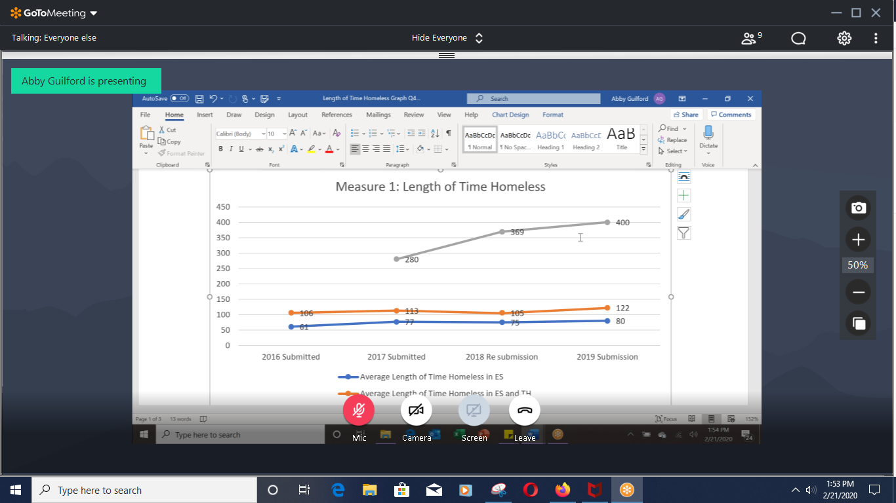

- Average Length of time homeless in ES – 80
- Average length of time homeless in ES and TH – 122
- Average length of time in Homeless in ES, TH, PH – 400
- Goal is to decrease by 5%
Measure 2 – Returns
Shelter has the highest rate of return to shelter.
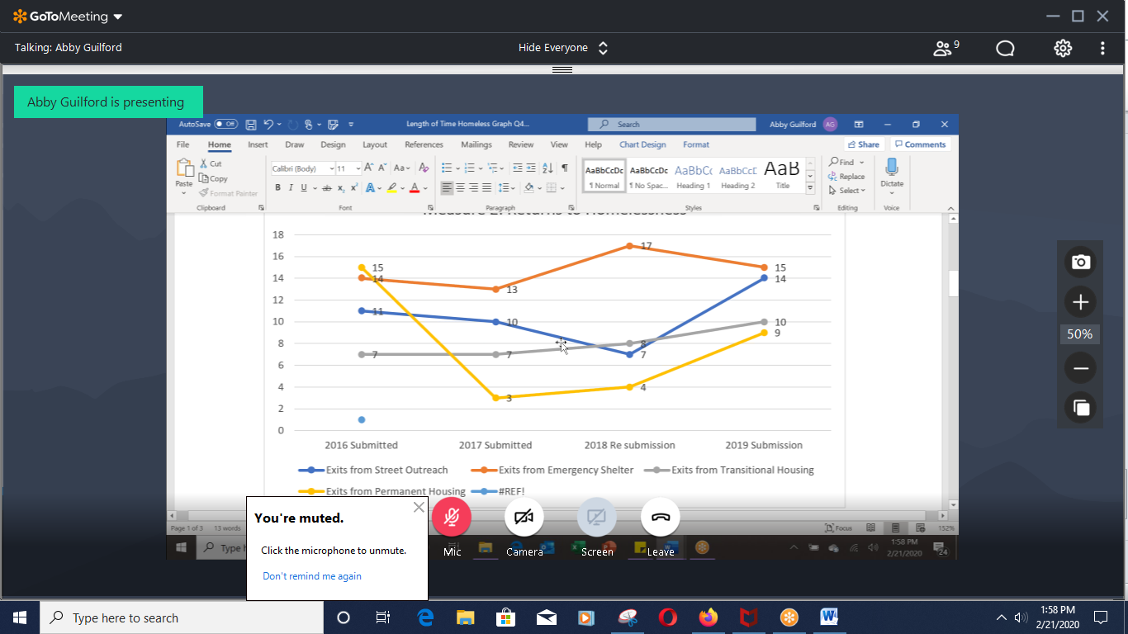
Measure 3 .1 PIT
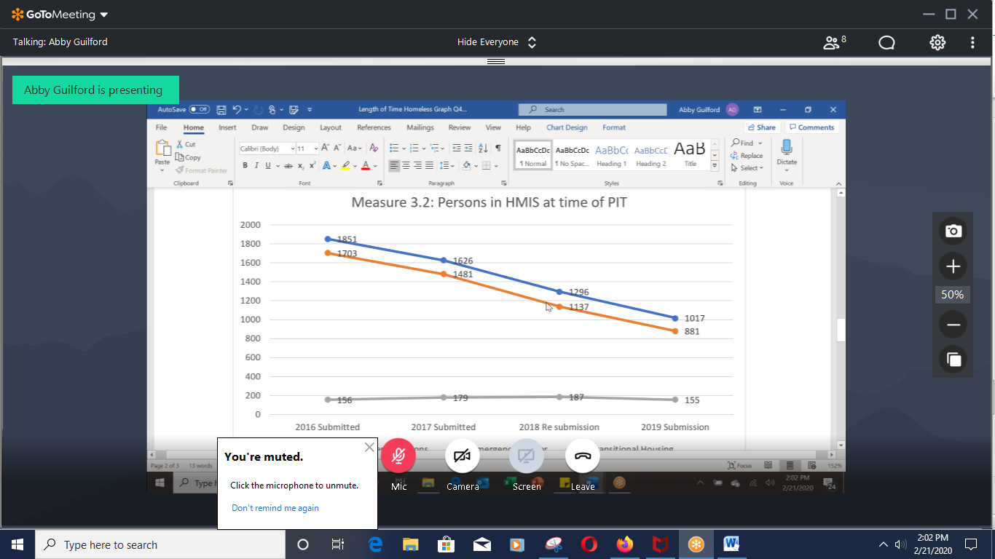

Measure 4 –Income
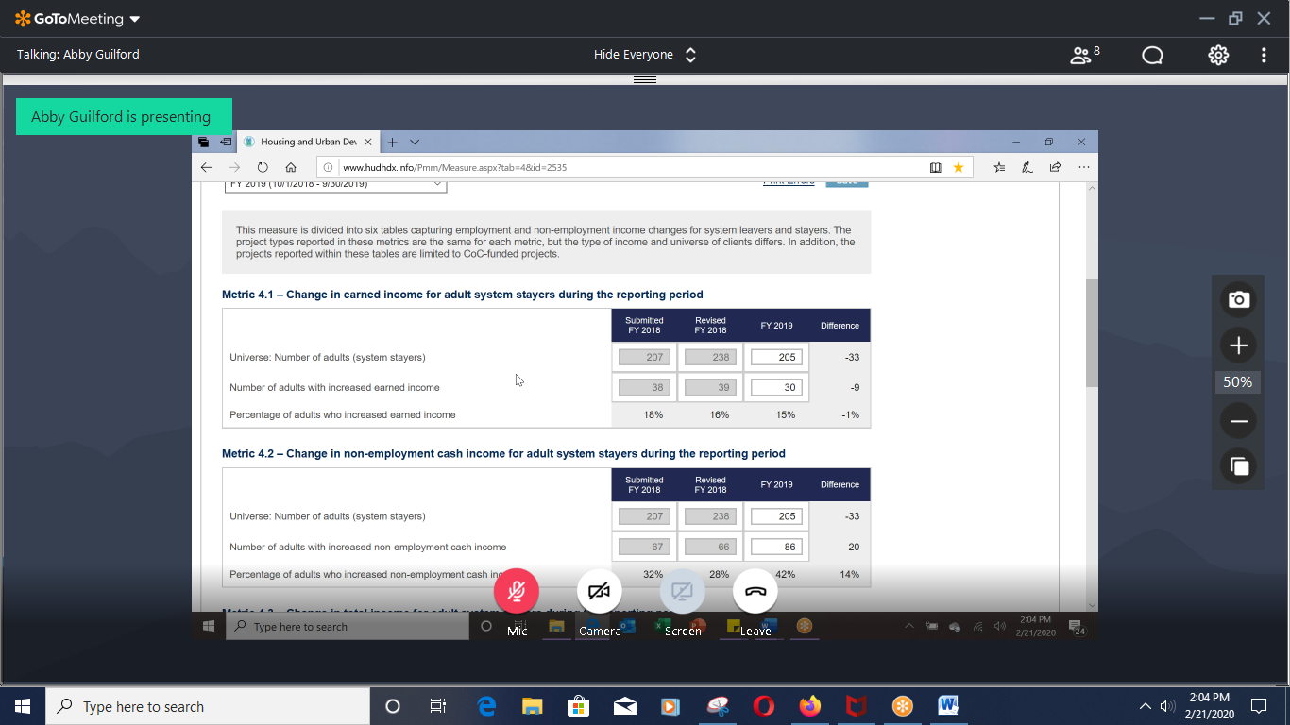

Measure 5 – Persons experiencing homelessness for the 1st time
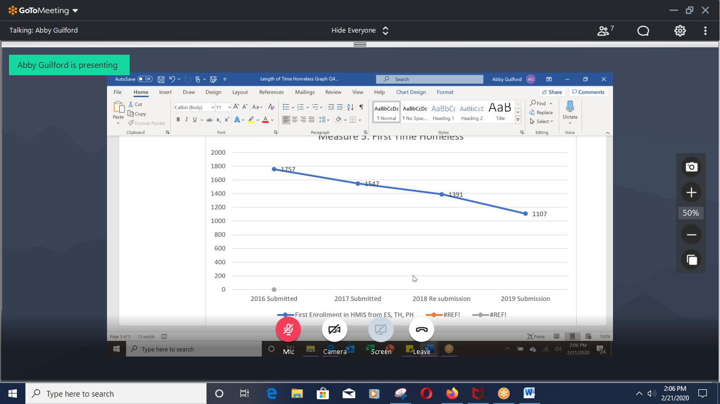

Measure 7- Successful exits
- Decrease in Shelter
- Same for ES, SH, TH and PH-RRH
- PH decreased

Motion to adjurn: Heather
2nd Eric
Approved

