Coordinated Entry Instructions for Adding a NEW Entry/Exit

Always Enter Data As (EDA) to the correct provider

- You can use Current System Date; you do not need to be in backdate mode to carry out this task. (Pro tip: You don’t need to be in backdate mode for any task on the Entry/Exit tab!)

- Enter the client’s record using the Client ID

- Click on the Entry/Exit tab

- Click on Add Entry/Exit* – *Only if you do not already see an open entry to a provider labeled “…SMC- Coordinated Entry Assessment” or something similar. If they already have an entry, skip to “Instructions for adding an Interim Update”
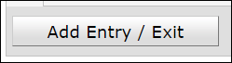

- Household Members: Check the box next to the name of every household member identified by the head of household at the time of assessment.

- In the next pop-up:
  - Provider: Leave as is; should match your Coordinately Entry provider
  - Entry Type: Select Basic.
  - Project Start Date: date the client was assessed

- Click on Save and Continue.

- Complete assessment. If any fields are already filled in, skip them ONLY if what is written is still accurate. Do not worry about messing up someone else’s data. In the E/E tab, this is not a concern – you are only changing data in your entry/exit.

- Click Save and Exit. PSA: Never click on Verify and Save!

Instructions for Adding an Interim Update
4a. Locate the open CE Entry/Exit, and click on the Interims icon
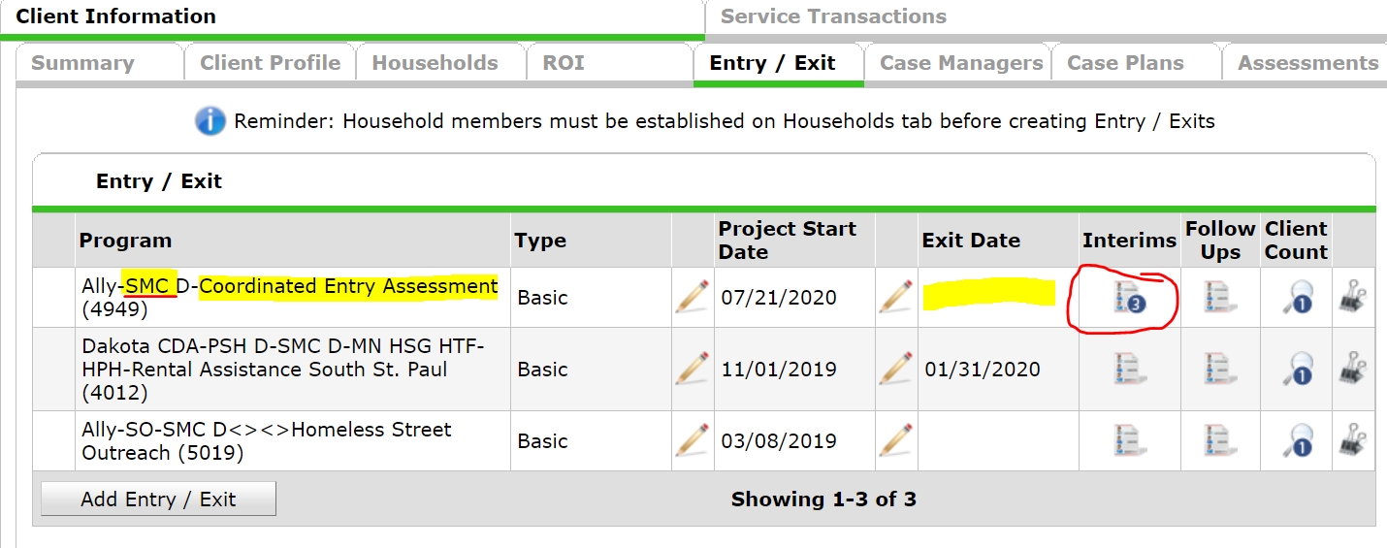
5a. Click on Add Interim Review

6a. In the next Pop-up
Interim Review Type: Select Update
Review Date: Enter the date you talked to the client

7a. Click on Save and Continue

8a. Ensure there is an active row in the CE Assessment sub-assessment, and that the Prioritization Status says Placed on Prioritization List.
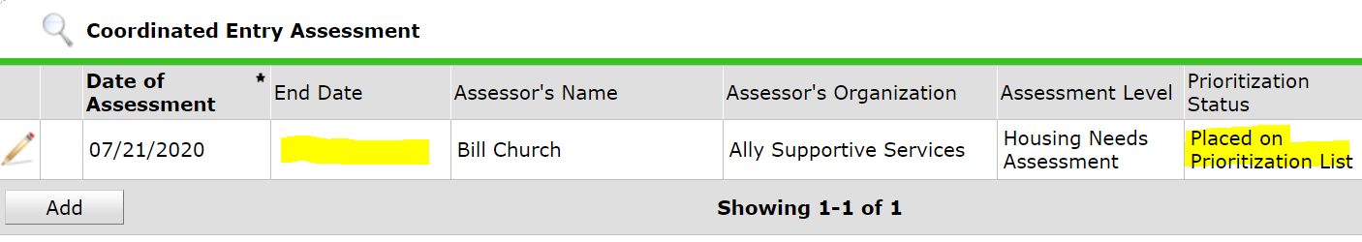

9a. Update any fields in the CE Assessment that need updating including:

  - Contact info
  - Income
  - Housing history
  - Current Living Situation
  - Assessing Chronic Homelessness question series

10a. Click on Save and Exit. PSA: Never click on Verify and Save!

