SMAC CES Committee Agenda & Minutes
  - November 14, 2019
  - 9:00-11:00
Children’s Home Society 1605 Eustis St., St. Paul
Conference Phone: +1 (669) 224-3412 Access Code: 699-295-573

- Introductions 5 minutes

- Director’s council update - Liz 5 minutes
  - MESH Fiscal Agent
  - Client Engagement Committee will meet to organize recruitment for council.

- New Access Point update - Liz 5 minutes
  - Application –
- Streamlined application process to ensure quality of assessments and strategically create access points to fill coordinated entry provider gap or community need.
- Reviewed Questions and Recommended for existing projects
to complete the application.
  - Advisory Approval- New applications will be processed by Advisory for approval.

- Advisory Update - Liz 5 minutes
  - Email recommendations, FAQ.
- Variance Request FAQ will be added to SMAC Website.
  - Upcoming changes with youth list
- Liz/Steve will be following up with youth providers to transition making referrals from street works, to hearth connection.
- PLM Changes will be implemented in January for youth providers.

- New system mapping - Liz 55 minutes
  - Current numbers and PL issues
We are 3x over the number of vacancies we have. We do not have enough housing for the people we are assessing. Liz shared Slides for averages.

  - Brainstorming opportunities for clients:
- What do we want our CE system as a count or a system to make referrals?
- Suggested that we look more closely at couch hopping as the majority of people that remain stagnant on the list.
- Identifying the need and completing the assessment – being upfront that the need may not be met.
- Increase Problem Solving Response to homelessness in a phased approach to include meeting immediate needs, and attempt to resolve prior to completing CE assessment.
- Suggestion: Assessor/Navigator providing all open waitlist as options, with the awareness to not solely rely on this. Also, connect person to other resources in the community that would assist with stability where they are currently at if they are couch hopping, outside,
- Recommended that we balance trauma informed care with also having a concrete way to identify the need presented in our communities. Utilizing CES to capture data as a count has been essential to get increased funding on state, and local level.

- ABBY SYSTEM DRAWING/ MAPPING : Hud Requires our system to have these 3 components: Access, Assess, and Assign.

- 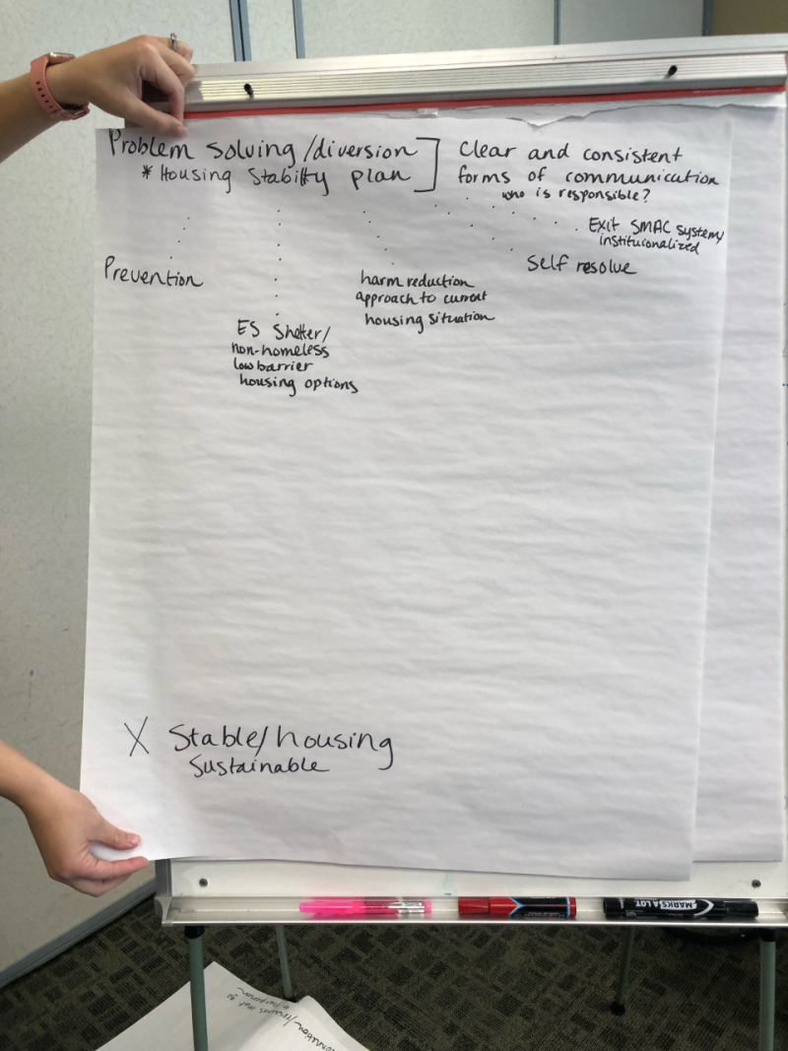

- Assessors- guidance and training for prevention or diversion : currently there is nothing being offered from the SMAC level. Assessor input - prevention efforts are being made as needed, often after the CE Assessment has been completed.

- System needs to increase Transparency- we have a lot of our system that isn’t transparent how people get into shelter, how people get into prevention, ect.

- Figure out how HMIS can capture/document need, and effectively create priority list – So those 2 data elements exist separately in HMIS.

- Prioritization for Housing stabilization services – for a system to allow phases of support to be offered – in place of our binary CES response that only offers an assessment to determine need.

- Want to make sure that people do not have to earn a housing assessment – which would create more barriers.

- Assessment tool discussion - Steve 40 minutes
  - Moving away from the VI-SPDAT
    - C4 study (attached) and Governing Board request
- The way in which questions are asked, and the types of vulnerabilities captured are not culturally responsive.
- The Tribal Collaborative was providing this feedback well before the C4 study.
- Statewide tool group – agreement across all COC that the VI-SPDAT will not be a the tool we continue to use. The Question is do we move away sooner or later. If so, COC will need a way to prioritize.
- Recommendation – take VI – SPDAT off and use assessment as is – along with case consultation for prioritization.
- Can we add prevention tool to HMIS? System Mapping could incorporate.
- Equity- conversation with case consultation – how do we remain intentional in not recreating the same system response in a different way?
- Logistical Time Frame – Implement New Work Flow April 1, 2020
- Roll out implementation changes with offering training and effective communication.

- Recommendation of SMAC CES Workgroup: Recommendation – Remove VI – SPDAT vulnerability questions off and use assessment as is - along with case consultation for prioritization.

b. HUD Requirements

- Review Actions/Next Meeting 5 minutes
  - PIT – No updates were provided.

