SMAC CES Committee Agenda
December 12, 2019
9:00-11:00
Children’s Home Society 1605 Eustis St., St. Paul
Conference Phone: +1 (669) 224-3412 Access Code: 699-295-573
Attendance: Liz, Abby, Steve, Michelle, Natalie, Betty, Sheena, Jennifer, Jen Romero, Rachel, Peter, Lisa, Dana, Terri, Heather, Daryl, Racheal from cap, Katie cap, Matt, Doreen

- Introductions 5 minutes

- Director’s council reminder 5 minutes
Updates:
- Sent out interest form for Directors council, please circulate.
- 3 interest forms completed.
- Could start as early as the end of December – Don’t wait to submit interest forms.

- Advisory structure 15 minutes
  - Current language includes “3 Priority List Managers, 1 PSH provider, 1 RRH provider, 1 administrator, and 1 assessor.”
  - In January, CES grant changes from 3 PLMs to 2 CE staff and 1 navigator
  - CES Workgroup Make recommendation to Governing Board on Friday, Dec. 20.

Updates:
- We are working towards the CE group making a shift to be under the hearth connection umbrella.

- System Mapping 45 minutes
Updates:
- slides from Liz
- HUD’s Requirements: Access , Assess, Assign are the 3 Components that need to be included in homeless response system.
- Discussion Notes: for System Mapping:
- 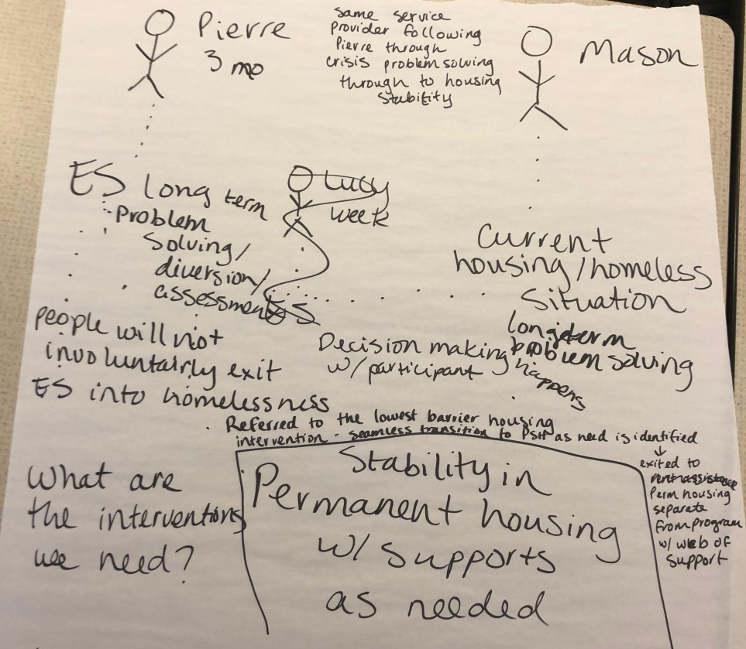

Start today with Shelter and Harm reduction approach to current housing situation:
1 person (Pierre) shelter route: 1 person (Mason) remaining in current situation:
Shelter to housing longterm/problem solving
Diversion at every point of the process Permanent housing
Connection with person/support at every step
Beginning crisis diversion
Leading towards longer term diversion
Relationship building – same service provider to follow them
Transitional Housing for Youth
Both People: Decision Making happens with participant

Liz: How do we integrate what worked before and with CE System?
- Progressive Engagement: to build a system to that can continually reassess people and either decrease or increase support. Streamlining the system to graduate people.
- Clients don’t have to return to homelessness to get more supportive housing options.
- There is a seamless process that can be flexible, with the needs of the client.
- Other Important Issues to address regarding decision making:

  - How people get from prevention to ES or shelter or currently where they are at.
  - Are there decision making advancements we could make to lessen the amount of clients ending up on the priority list.

- More immediate system improvement 45 Minutes
  - What is our plan for keeping our list in control before our new system map is fully implemented?
  - Communication Plan

Updates:
- How can we start/what parts of this can we start right now. Interim solutions to get to the bigger plan:
- Go upstream: to taper support for as needed and graduate to higher levels of support
- Assessing Barriers/preferences and problem-solving with client prior to completing assessment.
- Used HMIS more robustly to capture/quantify needs separate from the list.
- HMIS: Rolling in more front end support – and at some point could then be entered in under a step 2.
- HMIS: Reinvent Step one to capture information to assist with decision making with client that could identify options to resolve the crisis that may or may not include completing assessment to be added on the priority list.
- Assessors: Front end asking more questions to problem solve along with more training on resources.
- Look at ways to develop more equitable access to housing resources.
- Pohlad Funding: Explore grant as a COC rather than Scott County.
- Options for maintaining the list: Automatic removal regardless of time line is an option, set a 90day timeframe to automatically remove people, just add them back if it they engage.
- Make an initiative for assessors to create diversion goal of 2-3 people a month to resolve outside of CE.

- Review Actions/Next Meeting 5 Minutes
FOLLOW UP ITEMS FOR JANUARY:
- Work towards developing new step one : Phrasing of Questions
- Decide on proposal for list removal: test run of shortening 45 day window to 14 days. Make inactive and can reactivate if they re-surface. Along with implementing these changes attempts will be made to exhaust all possible means of contact.

