Suburban Metro Area Continuum of Care (SMAC)
Coordinated Entry Procedures

Purpose
The purpose of this document is to record the procedures completed by the SMAC Coordinated Entry Staff to ensure transparency and ease of transition. The intended audience is service providers interacting with Coordinated Entry and relevant staff at each of the 5 metro counties.

Contents
Section 1: Implementation and Planning…………………………………..………………………………..………1
Section 2: Marketing/Education/Training and Support………………………………..……………..………3
Section 3: Access and Assessment.........…………………………………………..……………………..………….5
Section 4: Prioritization…………………………………………………………………..…………………..……………..6
Section 5: Housing Referral…………………………………………………………………………….….……………….8
Section 6: Priority Pool Maintenance, Move Up…………………………………………………...….…………9
Section 7: Reporting/Evaluation………………………………………………………………………….…….……….9
Section 8: Data Privacy and Data Sharing…………………………………………………………………………10

Section 1
IMPLEMENTATION AND PLANNING
__________________________________________________________________________________________________

Workflow Chart
Directors Council
Directors Council makes recommendation to Governing Board
Directors Council sets priorities of work for CES Committee

Governing Board
CES Committee

CES creates list of options for Directors Council to review.
Governing Board votes on Directors Council Recommendation, sends to CES Committee for implementation

Governing Board
For the Governing Board procedures, see SMAC Bylaws.

CES Committee
- Meets monthly
- Group attendance is open to anyone who has an interest in understanding or affecting the working of the SMAC Coordinated Entry System.
- Led by CE Staff, in collaboration with the Chair, Vice Chair, and Secretary.
  - Officers are elected yearly, nominated by the CES Committee and approved by the Governing Board.
- Agenda is created in a yearly workplan with the CoC Coordinator.
  - Changes in workflow priority are made in collaboration with the CoC Coordinator, the CE Planners and input from the previous Work Group meetings.
  - Agenda and calendar invites are distributed by the CE Staff.

CES Advisory Committee
An assessor or housing provider may submit a Variance Request to the Advisory Committee when they feel the standard CES workflow is not appropriately serving a client. The Advisory Committee discusses ideas to better serve the client, as well as come to a consensus on whether to approve or deny the variance as it relates to the desired outcome specified.
- Elected group of stakeholders include:
  - Two SMAC CES staff
  - one Navigator
  - one assessor and/or outreach worker
  - one RRH provider
  - one PSH provider
  - one administrative person.
- Any member who has or had a significant working relationship with a household discussed or may have a vested interest in the outcome a particular variance, will recuse themselves for that variance request.
- Membership is reviewed annually
  - Vacant seats are filled as needed
    - Members are solicited by the CE Planner and/or CoC Coordinator.
    - The CES Committee recommends membership
    - Governing Board approves membership

CE Staff leads each meeting, which consists of:
- Disseminating variance requests collected through the week
- Facilitation
- Documents recommendations, solutions, and votes
- Assigns communication of disposition to requestor
Quarterly, The Advisory will report trends and outcomes to CES Committee.

Directors Council
- The CoC Coordinator and CE Staff secure funding to reimburse for gas/transportation, meals, and time spent attending meetings.
- Members are solicited by the CE Planner through connecting with service providers
  - Interested individuals submit an interest form and meet one-on-one with CES Staff or CES Committee member to discuss purpose and answer questions.
- Goal is to have between 8-12 Directors.
- The Council meets twice per month for 1 hour, and Directors are paid $15/hour for participation and provided with transportation assistance as needed.
- CE Staff sets the agenda for the meetings in consultation with the Directors.

Section 2
MARKETING/ EDUCATION/ TRAINING AND SUPPORT
__________________________________________________________________________________________________

CES Communications
- CE Staff puts out a monthly newsletter via email to everyone who has signed up via the SMAC website, including news from CES Committee and the Governing Board.
- At least once per year, CE Staff will meet 1:1 with each agency participating in coordinated entry to check-in and offer support.

Service Provider Support
At least yearly 1:1 with each agency to discuss:
- Successes and struggles
- Feedback on CE and general system
- Feedback on communication and trainings
- New initiatives

Trainings

Coordinated Entry Workshops
Coordinated Entry Workshops are put on by CE Staff, held in a central location (usually St. Paul) to accommodate transportation for all 5 counties. The meetings are organized by CE Staff, in collaboration with solicited work from a diverse subset of community partners. Community partners share the responsibility of presenting material with CE Staff. They are broken up into two sections: Large group updates and small group breakout sessions.
- The large group focuses on data updates, policy updates, progress toward goals
- Breakout sessions include:
  - Intro to SMAC
  - HMIS Question and Answer, in collaboration with SMAC representative for ICA.
  - Housing Provider support
  - Resource sharing / networking
Breakout sessions are used as a time for direct service staff throughout the region to ask questions, get clarity on policies and procedures, and learn from each other.

Online Training
CE Staff develop online training content for Service Providers and the broader community, including:
- SMAC Introduction
- Coordinated Entry Introduction
- Dynamic Prioritization and Rapid Resolution
- Assessor Training videos

CE Assessor Training
CE Staff responsibilities:
- Develop online training content and makes available via the SMAC website
- Develop and evaluate certification quizzes as it relates to CE Assessor Training content
- Monitor training completion and sending of training reminder emails.
- Solicits feedback on training material effectiveness

Section 3
ACCESS AND ASSESSMENT
__________________________________________________________________________________________________

CES Workflow
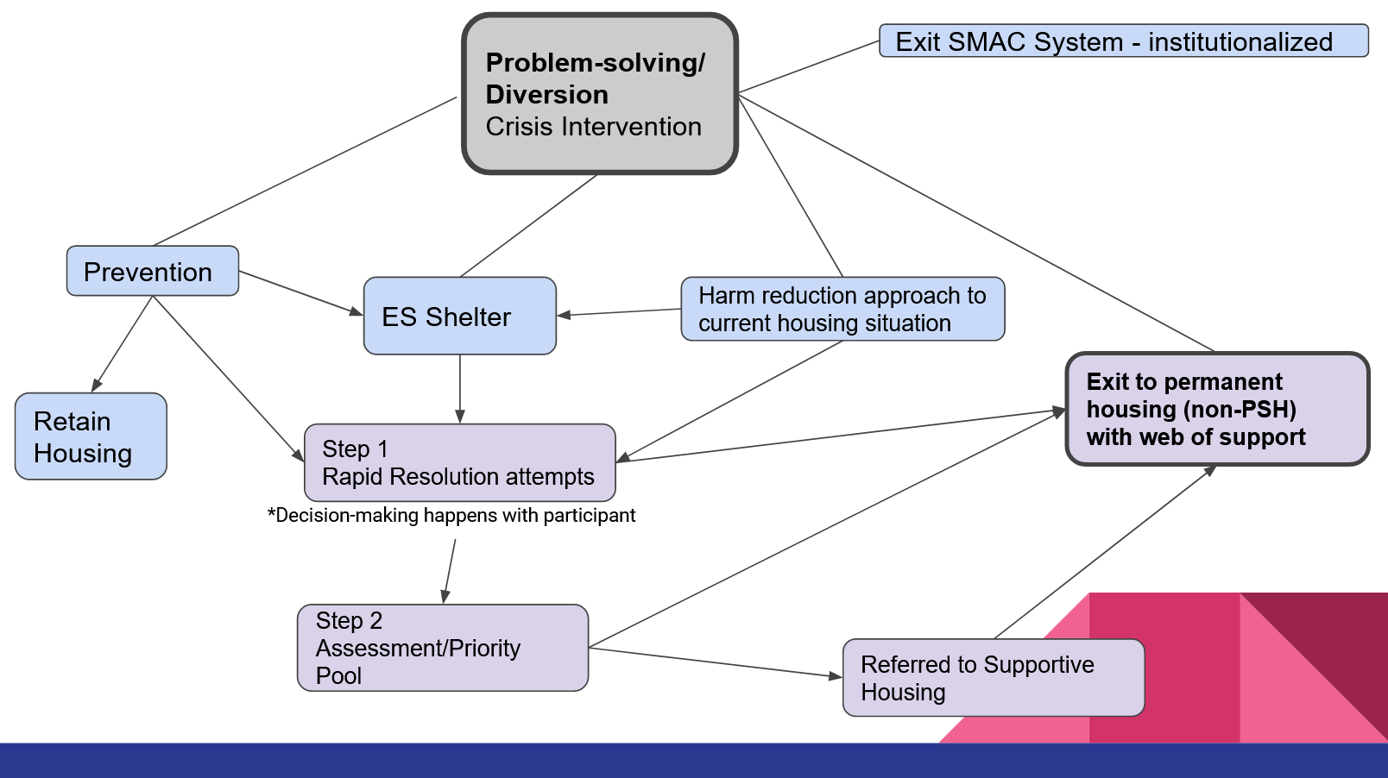

Access Development and Evaluation
CE Staff will evaluate data from PIT, CE, and general demographic data to determine where additional Access Points are needed. CE Staff will work with CES Committee and local Heading Home groups to recruit new Access Points.

Assessment Development and Evaluation
CE Staff will develop a process for Assessment Development and Evaluation in partnership with the CES Committee and other Metro and Greater MN CoC staff where appropriate.

SMAC/Ramsey Assessment Group
This group is responsible for vetting any proposed changes to the SMAC/Ramsey Step 2 Assessment.
CE Staff responsibilities:
- Facilitate quarterly meetings
- Ensure proper representation from each CoC
  - 3 from Ramsey, 3 from SMAC, and 1 assessor who operates in both
- Communicate outcomes to SMAC CES Committee

Section 4
Prioritization
__________________________________________________________________________________________________
Prioritization is determined by input from the Coordinated Entry Committee, CES Staff, the Data and Evaluation Committee, and the Governing Board.
All households will be prioritized by the following criteria:
- Chronic Homeless (HUD)
- Youth (HoH aged 16-24)
- Months Homeless (HUD)
- Months Homeless (MN)
- MN Long Term Homeless Definition

Case Consultation
Case Consultation is a weekly call-in meeting organized by CE Staff that includes representatives from SMAC Counties, access points, housing programs, and outreach. The purpose of this call is to discuss ways to eliminate barriers for clients in the priority pool who may be close to receiving a referral, circumstances requiring flexibility with normal CES workflow, or any other household deemed a high priority.
- CE Staff identify clients for the Case Consultation from the Priority List report from HMIS.
  - CE Staff target households using the following criteria:
    - Households closest to the top of the report
    - Holdovers from the prior week,
    - Clients who have refused housing programs or who have been denied by housing programs, or
    - Other identified clients who show a pattern of returning to the system.
  - CE Staff place about 40 clients on the consultation call, varying slightly week to week
- Clients are placed by CE Staff onto the Case Consultation spreadsheet.
  - Active tab is for households being considered high priority for Supportive Housing
  - Inactive tab is for households who are housed, referred, or no longer eligible to be in the Priority Pool, OR have been confirmed to no longer be the highest priority.
- CE Staff email the new consultation list (HMIS ID and Initials) one week prior to the call to every assessor or agency who had recent contact in HMIS.
- CE Staff holds the meeting via GoToMeeting, discussing clients by their initials and HMIS IDs to protect privacy.
  - Only HMIS users may attend due to the HMIS ROI.
  - CE Staff adds notes in the Case Consultation spreadsheet for the date of the call.
  - If clients are removed from Case Consultation, their row on the spreadsheet is moved to an inactive tab

DV Case Consultation
A separate phone call is held monthly to discuss households in the Priority Pool who are fleeing or attempting to flee Domestic Violence or Sexual Exploitation. The purpose of this consultation is general problem solving, supportive housing referral prioritization, and expanding staff understanding of SMAC and Coordinated Entry as well as DV services. To protect client privacy/safety, typically only DV assessing agencies and CE Staff attend this meeting.
- Shelter staff identify clients at their shelter who don’t have a housing plan and who have completed a Step 2 assessment.
- CE Staff notify other CE Assessors who have assessed someone in the past month who is flagged as fleeing DV, giving them the opportunity to attend this meeting.
- All clients discussed must have signed the SMAC CE Case Consultation ROI.
- CE Staff holds the meeting via GoToMeeting, discussing clients by first name and last initial to protect privacy.
- Staff records notes, including outcomes, on the Case Consultation tab of the non-HMIS Priority List.

Management of the List Outside of HMIS
- CE Staff enters the data from the assessment to the non-shared list.
- The non-shared list contains the same elements as the HMIS list.
- For each vacancy, the non-shared list is reviewed in conjunction with the HMIS list, and referrals are made based on overall priority between the two lists.
- Households currently fleeing DV will be added to the DV Case Consultation list if they signed the CE ROI, found on the SMAC website.
- Households not currently fleeing DV who are high priority will be added to regular Case Consultation if they signed the CE ROI, found on the SMAC website.
Veterans
- CE Staff attend Veteran Registry calls whenever possible.
- When a new Vet is identified on a Registry call who is not eligible for VASH or SSVF, CE Staff add them to Case Consultation.
- CE Staff cross-reference Registry with HMIS and alert Registry of discrepancies on a quarterly basis.

Transition Plan
If a household is at high risk of losing their program and returning to homelessness during the course of their housing program, the housing provider may request a program transfer.
Housing Provider completes Variance Request Form and sends to CE Staff
CES Advisory discusses Variance Request and provides recommendations or approval
Housing Provider notifies CES of client desire/need to transfer

CE Staff asks programs if they have openings for a transfer

Variance Request Form is located on the SMAC website.

Evaluating Prioritization
Effectiveness of prioritization is tracked by CE Staff and reported to the CES Committee, Governing Board, and at CE Workshops. CES Committee makes recommendations to the Governing Board whether to maintain or adjust prioritization. If prioritization needs to be adjusted, solutions will be discussed by the CES Committee and the Directors Council and presented to the Governing Board.

Section 5
Housing Referral
__________________________________________________________________________________________________

Reporting a Vacancy
Create and maintain Vacancy Report Form, including
  - Number of vacancies
  - Max occupancy (single, couple, family)
  - Shared/ Not Shared
  - Category of vacancy (RRH, PSH)
  - Gender (if applicable)
  - Homeless definitions accepted
  - Residency requirements (if any)
  - Unit eligibility, as per funding requirements
- In addition to the criteria above, the CE Staff bases the referral on the program’s eligibility criteria, as published on https://smacmn.org/coordinated-entry/.

Filling a Vacancy
CE Staff sends Referral Form via email to HP, cc’s assessor, and records referral in HMIS
Housing Provider (HP) notifies CES of program vacancy
HP completes steps in HMIS and reaches out to client to confirm eligibility and interest in program

If denied
HP returns Referral Form via email to CE Staff with Outcome fields completed

Tracking Referral Outcomes
CE Staff track the following data:
- Date of initial request
- Who made the request
- Number of vacancies
- Client referred
- Date of referral
- Outcome of referral
- Date of acceptance/denial
- Reason for denial if applicable
- Subsequent attempts to fill vacancy

CE Staff share referral outcomes with CES Committee on a quarterly basis

Section 6
Priority Pool Maintenance, Move Up
__________________________________________________________________________________________________

Priority Pool Maintenance
In order to maintain an accurate Priority Pool:
- CE Staff emails each assessing agency the first week of the month with a list of all clients they assessed who have been in the pool for 90 days or more. Access points attempt to reengage with clients to:
  - Determine if they still need to be in the priority pool
  - Remove them from the pool if they no longer need or want to be there
  - Document attempts of engagement in HMIS under “Assessors Notes.”
- CE Staff monitors follow through by checking HMIS.
- If a client does not reengage, CE Staff will refer to CE Navigator or Case Consultation to follow through with repeated attempts as per the policy to remove a client from the list.

MOVE UP to Housing Choice Voucher
- PHA notifies CoC of voucher availability.
- CE Staff reach out to housing providers to identify clients who are eligible for the Move Up program. CE Staff will not maintain a list, but solicit for eligible clients as vouchers become available.
- Housing providers complete Metro Assessment Tool* with eligible households and upload in HMIS and/or submit to CE Staff with ROI to PHA.
- CE Staff prioritizes based on Metro Assessment Tool* score
- If tie-breaking is needed, CES Advisory determines final referrals to PHA.
- CE Staff emails HMIS IDs of selected participants to both PHA and housing providers so they can coordinate.
*The Metro Assessment Tool was developed specifically for Metro HRA’s Move UP initiative of 2020. Future initiatives may or may not include this tool.

Section 7
Reporting / Evaluation
__________________________________________________________________________________________________
CE Staff request ICA run the CE Monitoring report quarterly. CE Staff analyze the report for the following elements:
- Number entering CES (Step 1 and 2)
- Number exiting CES (Step 2)
  - Destinations
CE Staff track number of households in Priority Pool monthly, broken down by priority, HH type, and County of Primary Residence. SMAC CE team discusses on a monthly basis.

Section 8
Data Privacy/Data Sharing
__________________________________________________________________________________________________
CE Staff utilize a number of practices to ensure data privacy, including the following:
- Maintaining a SMAC-wide Release of Information (ROI) which is gathered from all households by Access Points.
  - The ROI is updated yearly to include any new partner agencies.
- When referring to clients in case consultation or via email, only utilizing the clients’ initials and HMIS ID number to protect privacy.
  - This also includes referral documentation.
  - When clients are not in HMIS, only utilizing first name and last initial where possible.
- Ensuring that all participants on the weekly Case Consultation call are HMIS users, who are covered in the HMIS ROI.

