Suburban Metro Area Continuum of Care (SMAC)

HUD Continuum of Care Homeless Assistance Grants

2023 NOFO Competition

2023 Local Materials Packet for Agencies Applying
for Renewal Projects

September 2023

CONTEXT
The Continuum of Care (CoC) Program (24 CFR part 578) is designed to promote a community-wide commitment to the goal of ending homelessness; to provide funding for efforts by nonprofit providers, States, and local governments to quickly re-house homeless individuals, families, persons fleeing domestic violence, and youth, while minimizing the trauma and dislocation caused by homelessness; to promote access to and effective utilization of mainstream programs by persons experiencing homelessness; and to optimize self-sufficiency among those experiencing homelessness.
Each year the U.S. Department of Housing and Urban Development (HUD) releases a Notice of Funding Opportunity (NOFO), signifying the beginning of a funding competition among approximately 450 Continuums of Care (CoCs), the community stakeholder groups that guide local responses to homelessness.

The FY 2023 CoC Competition consolidated application responses to the NOFO will consist of three parts: the CoC Application, which describes the CoC planning body governance structure, overall performance, and the strategic planning process; the CoC Priority Listing, which ranks the project applications for HUD and identifies any rejected applications, showing the CoC’s priorities for funding; and a number of Project Applications, each of which reflects one project seeking funding.

Before the application is submitted to HUD, the CoC is required to hold a local competition to determine which project applications will be included in the consolidated application, along with their relative priority. The results of the local competition dictate which projects the CoC will prioritize. As a project applicant, you must participate in the local review and rank process and have your project selected for submission with the CoC consolidated application in the national competition in order to be eligible for funding. You must follow local procedures and submit local documents, and you also need to prepare for the HUD submission of the project application. HUD requires the use of a web-based application and grants management system called e-snaps.
This TA Handbook contains information you need to know for the HUD process, and other materials provided contain information about the local process in this community.

There are three things to keep in mind when preparing your application:
1. Ensuring your application is competitive for funding in your CoC’s local competition; 2. Ensuring the project you are applying for is eligible for HUD funding and compliant with HUD requirements, and; 3. Ensuring your application is filled out correctly.

Table of Contents

I. 2023 Funding Overview and Tier 1 and Tier 2 System……………………………………………………………4

II. Local Community Project Review Process…………………………………………………………………………….5

II. Appeals Policy and Process…………………………………………………………………………………………………..7

III. SMAC CoC NOFO Application Timeline for Renewal Projects……………………………………………… 9

IV. 2023 Project Scoring Tool……………………………………………………………………………………………….….10

V. Renewal Project Applicant Submission Checklist………………………………………………………………..23

VI. 2023 SMAC NOFO Policies………………………………………………………………………………………………….24

VII. Racial Equity Measures……………………………………………………………………………………………………..26

VIII. Education and Early Childhood Policy Verification Form…………………………………………………….27

*Item VIII. MUST be submitted if your project serves families with children with your project application on August 14, 2023

2023 NOFO Funding Overview
On July 5, 2023, the U.S. Department of Housing and Urban Development (HUD) released a Notice of Funding Opportunity (NOFO) for the McKinney-Vento Continuum of Care Homeless Assistance Grants for FY 2023. In 2023, the Suburban Metro Area CoC expects to be eligible to apply for approximately $4,104,714 in funding to support housing and services for homeless households, and approximately $130,144 for CoC Planning Funds.
Annual Renewal Demand Funding: SMAC 2023 $4,104,714
This funding supports the CoC’s existing housing and services. The CoC has the option to continue to support those programs, or to reallocate those resources, in whole or in part, to Permanent Supportive Housing, Rapid Rehousing, Joint TH-RRH, HMIS, or Coordinated Entry (SSO) projects. (Details regarding eligible populations follows.)
Permanent Housing Bonus Funding: SMAC 2023 $287,330
This funding supports Permanent Supportive Housing, Rapid Rehousing, or Joint TH-RRH projects. (Details regarding eligible populations follows.)
Domestic Violence Rapid Rehousing Bonus Funding: SMAC 2023 $343,351
The DV Bonus is available to projects which will provide housing and services to survivors of domestic violence, dating violence, and stalking. The DV Bonus funding can support: Rapid Re-housing (PH-RRH) projects, joint TH and PH-RRH component projects as defined in Section II.B.5 of this NOFO, SSO Projects for Coordinated Entry (SSO-CE) to implement policies, procedures, and practices that equip the CoC’s coordinated entry to better meet the needs of survivors of domestic violence, dating violence, sexual assault, or stalking (e.g., to implement policies and procedures that are trauma-informed, client-centered or to better coordinate referrals between the CoC’s coordinated entry and the victim service providers coordinated entry system where they are different).
CoC Planning Funds: SMAC 2023 $205,236
This funding supports CoC planning activities, and only the collaborative applicant – MESH – may apply for it. The planning grant will not be ranked in this year’s competition and is not competitive with housing or service projects.

Tier 1 and Tier 2 System
Anticipated Tier 1 Amount: $3,817,384
Anticipated Tier 2 Amount: $918,011
As in past years, the funding that CoCs can apply for is divided into tiers, with projects prioritized in Tier 1 being more likely to be funded than projects of lower priority that are placed in Tier 2.
CoCs are required to either accept and rank or reject all projects submitted by project applicants in e-snaps, except CoC planning projects. CoCs are encouraged to consider the policy priorities established in the NOFO in conjunction with local priorities to determine the ranking of projects. All projects must pass HUD’s eligibility and threshold requirements to be funded, no matter their priority.
TIER 1: HUD will conditionally award projects from the highest scoring CoC to the lowest scoring CoC. Projects should be placed in priority order.
TIER 2: Tier 2 is the difference between Tier 1 and the maximum amount of renewal, reallocation, and CoC Bonus funds that a CoC can apply for.
Funding will be determined by using the CoC Application score as well as the factors listed in Section II.B.11 of the NOFO.
Tier 2 points are awarded as follows:
HUD will award a point value to each new and renewal project application that is in Tier 2 using a 100-point scale: (1) CoC Collaborative Application Score. Up to 50 points in direct proportion to the score received on the CoC Application; e.g., if a CoC received 100 out of 200 points on the CoC Application, the project application would receive 25 out of 50 points for this criterion.
(2) CoC Project Ranking. Up to 40 points for the CoC’s ranking of the project pplication(s). To consider the CoC's ranking of projects, point values will be assigned directly related to the CoC's ranking of project applications. The calculation of point values will be 40 times the quantity (1-x) where x is the ratio of the cumulative funding requests for all projects or portions of projects ranked higher by the CoC in Tier 2 plus one half of the funding of the project of interest to the total amount of funding available in Tier 2. For example, if a CoC is eligible to apply for projects totaling $500,000 in Tier 2 and applies for 5 projects ranked in Tier 2 of $100,000 each: the highest-ranked project would receive 36 points, and then the subsequently ranked projects would receive 28, 20,12, and 4 points.
(3) Commitment to Housing First. Up to 10 points for how the permanent housing project application commits to applying the Housing First model as defined in Section III.B.2. Dedicated HMIS projects and centralized or coordinated assessment system will automatically receive 10 points.
STRADDLING TIERS: For any projects that straddle the two tiers, HUD will conditionally select the project up to the amount of funding that falls within Tier 1. Using the CoC score and other factors described in Section II.B.11 HUD may fund the Tier 2 portion of the project. If HUD does not fund the Tier 2 portion of the project, HUD may award the project at the reduced amount, provided the project is still feasible with the reduced funding (e.g., is able to continue serving homeless program participants effectively).

2023 Local Community Project Review Process for Renewal Projects
- SMAC designs a project review process and the SMAC Governing Board approves it prior to the NOFO release.

- The SMAC Directors Council select a Monitoring and Evaluation Committee who will score and rank all the submitted project applications. All Monitoring and Evaluation Committee members must adhere to Article VII. of Suburban Metro Area CoC Bylaws and must not be associated with active applications in the 2023 CoC funding round.

- After the NOFO is released, the scoring document is updated to address any new priority elements of the NOFO. All changes are approved by the SMAC Governing Board at the next meeting. The Governing Board may give approval authority to the Monitoring and Evaluation Committee for changes to the scoring tool if timelines don’t allow waiting until the next Governing Board meeting.

- A notice will be sent via email to all project applicants when the NOFO is released with initial timelines, due dates, and the updated scoring tool.

- All projects will submit applications to the SMAC Coordinator, including a HUD project application and all required attachments (as detailed on page 22). All documents should be submitted electronically to Laquita Love-Limo at laquita@mesh-mn.org. Projects may be allowed to submit after the due date without penalty only with the written permission of the SMAC Coordinator.

- SMAC Coordinator conducts technical review of Project Applications and conducts initial scoring. In addition to project applications, the following items are used to inform scoring:
  - Project APR data submitted by project
  - Organizational Audit
  - Recent HUD audits and findings
  - LOCCS Drawdown and unspent funds
  - Project Educational and Early Childhood documents (families/youth)
- Projects are invited to amend applications based upon initial scoring. After the applications have been scored, the SMAC Monitoring and Evaluation Committee connects via phone or virtual platform with each of the project applicants to review their score. Amended applications are reviewed and scoring is adjusted. Where scoring is not adjusted, Monitoring and Evaluation Committee members will add narrative to the Applicant scoring sheet to explain underperformance and low scoring, as needed. Applicants will be reminded of the appeals process and the deadline for submitting an appeal.

- The Monitoring and Evaluation Committee meets together to rank projects into Tier 1 and Tier 2 based on score, historical performance, and other information gathered from meetings with the project applicant. It should be noted that the Monitoring and Evaluation Committee uses “scoring” and “ranking” as two distinct steps. Scoring informs but does not dictate the final ranking decisions. Where ranking and scoring do not correlate, the Monitoring and Evaluation Committee will provide comments to indicate why the project was ranked in their position.

- The Monitoring and Evaluation Committee may identify projects that should be reallocated, in whole or in part, in favor of a new project according to the SMAC 2023 NOFO Policies (Page 23).

- Projects facing reallocation will have additional appeal rights. (See separate Appeals Policy for more detail.) In addition, full comments from the Monitoring and Evaluation Committee will be made available upon written request after the competition closes on September 28, 2023. Projects can also report any discrepancies in their score sheet, although this is not considered an official appeal.

- The Monitoring and Evaluation Committee will publish their final ranking on the SMAC website no later than 15 days prior to CoC Application submission to HUD.

- Projects will submit their copies of letters or documentation for all match/leverage resources listed in their final Project Application submission to HUD. The SMAC Coordinator will be responsible for approving all Project Applications. Projects will be expected to provide quick response to fix missing information or errors in their Project Application at the SMAC Coordinator’s request prior to final submission.

- Applications will be submitted with the SMAC Collaborative Application.

Appeals Policy and Process

Applicants may appeal if:
- The project is not funded or receives less funding than the amount in the application;
- The project is ranked in Tier 2 of the CoC application (in which the applicants funding may be at risk);
- If the project falls into the bottom portion of Tier 1, as described below.
All notices of appeal must be based on the information submitted by the application due date. No new or additional information will be considered, unless the project is facing reallocation. Omissions to the application cannot be appealed. The decision of the Monitoring and Evaluation Committee will be final.
The Monitoring and Evaluation Committee will be made up of 11 SMAC community members approved by the SMAC Directors Council to serve on said committee. The Monitoring and Evaluation Committee will not have a conflict of interest with any of the agencies applying for McKinney Vento funding. The role of the Monitoring and Evaluation Committee is to read and review only those areas of the application being appealed.
PROCESS
- A preliminary ranked CoC Program funding list is posted.

- Each agency will have received a copy of their score sheet prior to the ranking being published. If a project applicant needs another copy, a request must be made to the SMAC Coordinator at laquita@mesh-mn.org within one (1) business day. Score sheets will be emailed to project applicants.

- Eligible Appeals: Any project that is 1) not funded or receives less funding than the amount in the application; 2) a renewal project that is ranked in Tier 2 of the CoC application (in which the applicant’s funding may be at risk); 3) falls into the bottom portion of Tier 1 that equals the Tier 2 amount may appeal the application’s score based on their score sheets. The preliminary CoC Program project funding list will indicate which applications fall into these categories at the time it is posted.

- Any and all appeals must be received in writing within the two (2) business day appeal period; therefore, all written appeals for applications that are eligible to appeal at the time the preliminary ranking list is posted must be received by September 6, 2023 by 3:00 PM via email.

- All notices of appeal must be submitted electronically to Laquita Love-Limo at laquita@mesh-mn.org.

- The notice of appeal must include a written statement specifying in detail each and every one of the grounds asserted for the appeal. The appeal must be signed by an individual authorized to represent the sponsor agency (i.e., the Executive Director) and must include (highlight and/or cite) the specific sections of the application on which the appeal is based. The appealing agency must specify facts and evidence sufficient for the Monitoring and Evaluation Committee to determine the validity of the appeal. That is, the notice of appeal must have attached the specific areas of the application being appealed and must also clearly explain why the information provided is adequate enough to gain additional points.

- If a program is facing reallocation, in part or in whole, the appealing agency may submit a more robust appeal. These appeals can include any information the agency feels is relevant, whether or not it was included in the project’s original application. The program will also be given the opportunity to make a brief virtual presentation to the Monitoring and Evaluation Committee.

- The Monitoring and Evaluation Committee will review and evaluate all notices of appeal and decide whether or not the appeal has any validity based on the appeal policy.

- All valid appeals will be read, reviewed and evaluated by the Monitoring and Evaluation Committee.

- The Monitoring and Evaluation Committee will hear any virtual presentations by projects facing reallocation. The appealing agency can send up to two (2) staff members to the presentation. The presentation is limited to 5 minutes. Following the presentation, the Monitoring and Evaluation Committee will have the opportunity to ask questions of the appealing agency. The results of the virtual presentation will not have an effect on the project’s rank; it can only be used to reverse a decision to reallocate funds. The decision of the Monitoring and Evaluation Committee will be released after deliberation.

- Monitoring and Evaluation Committee deliberates.

- Agencies will receive, in writing, the decision of the Monitoring and Evaluation Committee within 2 business days.

2023 SMAC CoC NOFO Timeline for Renewal and Transition Projects
Date & Time | Event | Action | Notes
Monday, June 19 | Intent to Apply due | Send to Laquita love-Limo at Laquita@mesh-mn.org | Renewal projects
Monday, July 17 | Call for New and Expansion projects sent out. Notice of due date for APRs and screenshots sent out. | Contact Laquita Love-Limo (laquita@mesh-mn.org) | New, expansion projects, renewal projects
Monday, July 31 | APRs, and screenshots of eLOCCS drawdowns and remaining funds due | Email to Laquita Love-Limo at Laquita@mesh-mn.org | Renewal projects
Monday, August 14 | Project application draft, attachments due to Coordinator | Email PDFs to Laquita Love-Limo at Laquita@mesh-mn.org | Renewal projects
Thursday, August 17 | Project Ranking Meeting | Online meeting | Monitoring and Evaluation Committee Members
Week of August 21 | M&E members meet with projects to review their scores | Meet with assigned M&E member | New, expansion, and renewal projects, M&E members
Thursday, August 31 | Initial Ranking is posted on CoC website | Online posting | New, expansion, and renewal projects
Wednesday, September 6 | Appeals due | Email to Laquita Love-Limo at Laquita@mesh-mn.org | Projects ranked in Tier 2
Friday, September 8 | All project applications drafts entered in e-snaps. | Done in e-snaps by applicants. Email PDF to Laquita Love-Limo at Laquita@mesh-mn.org DO NOT SUBMITT!!! | New, expansion, renewal, planning projects
Monday, September 11 | Voting to approve Project Ranking & Collaborative Application is completed. | Email voting | CoC Governing Board
Wednesday, September 13 | Final Project Ranking and CoC Collaborative Application posted on CoC website. | www.smacmn.org/nofo
Monday, September 25 | CoC Project Applications, Project Ranking, Project Planning Application and CoC Collaborative Application Submitted! | e-snaps
Friday, September 28 | ABSOLUTE Deadline to HUD

Project Scoring Tool

Each COC-funded project will be ranked using the SMAC Project Evaluation Tool. The scoring criteria is based on performance, both operations and project level. The information and data used to complete the evaluation tool includes CoC project annual performance report (APR) submitted in SAGE, ICA-generated HMIS reports, and CoC project applications. The maximum possible number of points a project can earn is 98 points for PSH projects and 92 for RRH projects.
Where do the points come from?
 | Category | Total Points Possible | Data Source | Percentage of the total
Part 1 | Project Performance – Operations  - Effective Use of Funds  - Drawdowns  - Unit Utilization  - Data Completeness  - Housing First | 28 points | SAGE APR  eLOCCS report  Project Application | 29% of total for PSH  30% of total for RRH
Part 2a – PSH only | Project Performance – PSH  - Chronic Homeless dedicated beds  - Exits to Permanent Housing  - Maintain or increase non-earned income  - Maintain or increase total income  - Reoccurrence (all exits)  - Reoccurrence (successful exits)  - Mainstream Benefits  - Health Insurance  - Coordinated Entry Denials | 38 points | SAGE APR  Project Application  ICA – SPM report  ICA – Returns report  CES Staff – Denials Report | 39% of total
Part 2b –  RRH  only | Project Performance – RRH  - Exits to Permanent Housing  - Increase earned income  - Increase total income  - Reoccurrence (all exits)  - Reoccurrence (successful exits)  - Mainstream Benefits  - Health Insurance  - Coordinated Entry Denials | 32 points | SAGE APR  Project Application  ICA – SPM report  ICA – Returns report  CES Staff – Denials Report | 35% of total
Part 3 | Project Performance—Racial equity  - Equity—Increase income overall.  - Equity—Exits to permanent housing.  - Equity—Returns to homelessness (12 months)  - Equity – Board/Leadership Composition  - Equity – Staff Composition | 32 points | ICA-  Self Report- | 33% of total for PSH  35% of total for RRH

**Annual APR data will be used. Projects will be required to submit an APR run for the following date range: July 1, 2022-June 30, 2023.

Point Breakdown:

Part 1: Program Performance – Operations (28 points possible)

Criteria | 8 points | 4 points | 0 points
- Effective Use of Funds | Spent 90-100% of grant | Spent 75-89% of grant | Spent less than 75% of grant

Source:
(1) Effective Use of Funds – SAGE APR, Q28. Financial Information
- Divide the Total Expenditures (not including match) by the Total Amount of grant awarded as documented in the HUD announcement
- In the example below: 113,250 divided by 115,000 = .98478 or 98% of grant was used
Total Grant Award $115,000.00

Criteria | 8 points | 0 points
- eLOCCS Drawdowns | At least 1 time per quarter | Less than 1 time per quarter
- Housing First | Yes | No

Source:
(1) eLOCCS drawdowns – submission by agency and/or request from HUD Field Office
(2) Housing First – questions found in CoC Project Application

Criteria | 4 points | 2 points | 0 points
- Unit Utilization | 90-100% | 80-89% | 79% or less
Criteria | 8 points | 4 points | 0 points
5) Data Completeness:  (a), (b), and (c) | All 3 are below 2.0% | 2 of the 3 are below 2.0% | 0 or 1 of the 3 are below 2.0% and/or one or more are above 5.0%

Source:
(1) Unit Utilization – SAGE APR, Q02. Bed and Unit Inventory and Utilization
- Add the four percentages together and divide by four to get the average unit utilization for the program year.
- In the example below: 38.89 + 33.33 + 55.56 + 50 = 177.78 divided by 4 = 44.445%

(2) Data Completeness – SAGE APR, Q06a. Data Quality: Personally Identifying Information (PII); Q06b. Data Quality: Universal Data Elements; Q06c. Data Quality: Income and Housing Data Quality
- To calculate each percentage:
- Q06a – overall score row & % of error rate column
- Q06b - % of error rate column for 5 elements (add and divide by 5)
- Q06c - % of error rate column for 4 elements (add and divide by 4)
- In the example below: (a) 0.02% (b) 0.00% (c) 0.00%

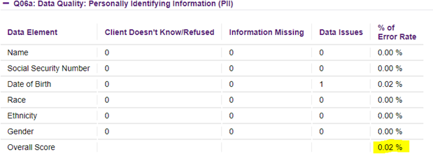
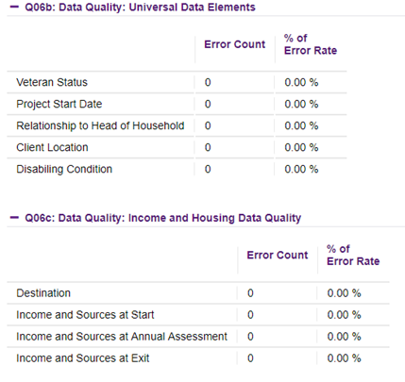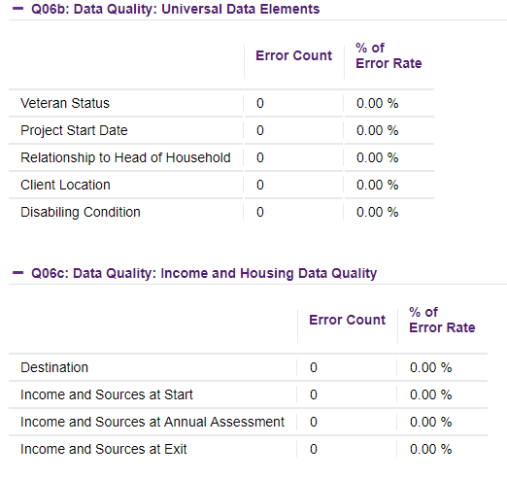

Part 2a: Program Performance – Permanent Supportive Housing (PSH) (38 points possible)

Criteria | 8 points | 4 points | 0 points
- Dedicated Chronic Homeless Beds | 90% or higher | 80 – 89% | 79% or less
- Housing Stability | 90% or higher | 80 – 89% | 79% or less
 | 2 points | 1 point | 0 points
- Non-Cash Benefits | 90% or higher | 70 – 89% | 69% or less
- Health Insurance | 90% or higher | 70 – 89% | 69% or less
- Maintain or Increase Non-Earned Income | 60% or higher | 50 - 59% | 49% or less
 | 4 points | 2 points | 0 points
- Maintain or Increase Total Income | 75% or higher | 65 - 74% | 64% or less
- Reoccurrence (SPM) | 0 – 10% | 10.1 – 20% | 0ver 20%
- Reoccurrence (Returns report) | 0 – 10% | 10.1 – 20% | 0ver 20%
- Coordinated Entry Denials | 15% or less | 11-25% | 0ver 25%

Source:
(1) Dedicated Chronic Homeless Beds - questions found in CoC Project Application

(2) Housing Stability – SAGE APR, Q23c: Exit Destination
- Find “Subtotal” for Exits to Permanent Destinations to get Answer A
- Add the number of stayers from Q22a1, column Stayers & row “Total” to Answer A to get answer B.
- Find “Total” in Q23c to get answer C
- Add the number of stayers from Q22a1, column Stayers & row “Total” to Answer C to get Answer D.
- Divide Answer D by Answer B to get the number of exits to permanent destination including stayers.
- In the example below:
- 1 (Answer A)
- 1+11=12 (Answer B)
- 2 (Answer C)
- 11+2=13 (Answer D)
- 12 divided by 13 = .923 or 92.3%

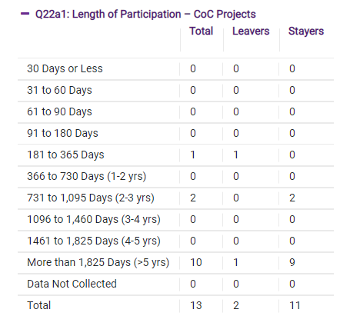

(3) Maintain or Increase Non-Earned Income – SAGE APR, Q19a1 and Q19a2: Client Cash Income Change – Income Source – by Start and Latest Status/Exit
- This measure only looks at the 3rd row “Number of Adults with Other Income.”
- Add number from 3rd column “Retained Income category and same $ at annual assessment/exit as at start” in 19a1 to number from to number from 8th column “Performance measure: Adults Who Gained or Increased Income from Start to Annual Assessment/Exit” in 19a1 for Answer A.
- Add number from 3rd column “Retained Income category and same $ at annual assessment/exit as at start” in 19a2 to number from 8th column “Performance measure: Adults Who Gained or Increased Income from Start to Annual Assessment/Exit” in 19a2 for Answer B.
- Add Answer A to Answer B to get Answer C.
- Add number from 7th column “Total Adults from 19a1 to number from 7th column “Total Adults” from 19a2 for Answer D.
- Divide Answer C by Answer D.
- In the example below:
- 4 + 11 = 15 (Answer A)
- 0+5 = 5 (Answer B)
- 5+15 = 20 (Answer C)
- 22+8 = 30 (Answer D)
- 20 divided by 30 = .6666 66.7%
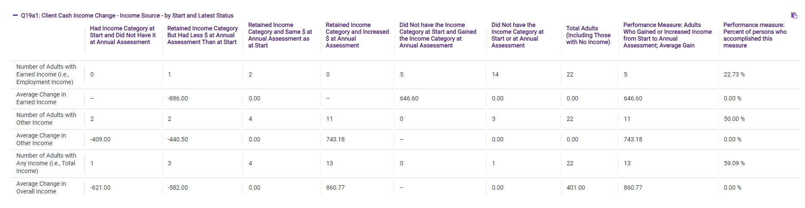

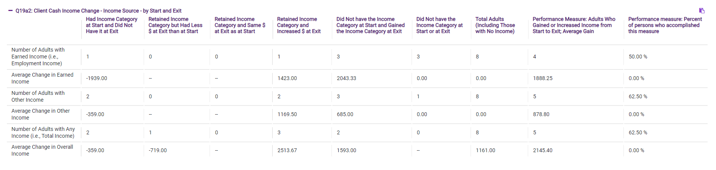

(4) Maintain or Increase Total Income –SAGE APR, Q19a1 and 19a2: Client Cash Income Change – Income Source – by Start and Latest Status/Exit
- This measure only looks at the 5th row “Number of Adults with Any Income (i.e. total income).”
- Add number from 3rd column “Retained Income category and same $ at annual assessment/exit as at start” in 19a1 to number from to number from 8th column “Performance measure: Adults Who Gained or Increased Income from Start to Annual Assessment/Exit” in 19a1 for Answer A.
- Add number from 3rd column “Retained Income category and same $ at annual assessment/exit as at start” in 19a2 to number from 8th column “Performance measure: Adults Who Gained or Increased Income from Start to Annual Assessment/Exit” in 19a2 for Answer B.
- Add Answer A to Answer B to get Answer C.
- Add number from 7th column “Total Adults from 19a1 to number from 7th column “Total Adults” from 19a2 for Answer D.
- Divide Answer C by Answer D.
- In the example below:
- 4 + 13 = 17 (Answer A)
- 0+5 = 5 (Answer B)
- 5+17 = 22 (Answer C)
- 22+8 = 30 (Answer D)
- 20 divided by 30 = .6666 %

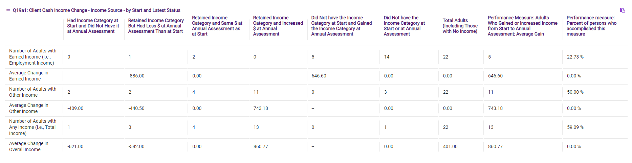
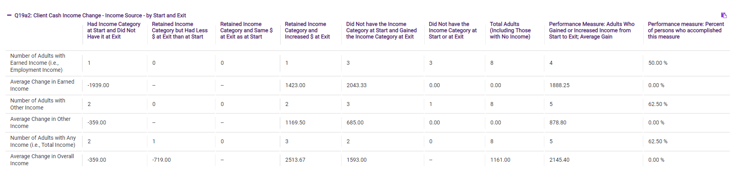

(5) Non-Cash Benefits – SAGE APR, Q20b: Number of Non-Cash Benefit Sources
- This measure only includes adults in households.
- Note the number of adults in the program from Q05a: Report Validation Table - number of adults (age 18 or over).
- Add number of people in row “No Sources,” column “Benefit at latest annual assessment for stayers to column “Benefit at exit for leavers.”
- Subtract from the total number of adults.
- Divide that number by the number of adults.
- In the example below:
- Number of Adults = 17
- Number of No Sources “Benefit at latest annual assessment for stayers” = 3
- Number of No Source “Benefit at exit for leavers” = 2
- 3+2 = 5; 17-5 = 12; 12 divided by 17 = .7058

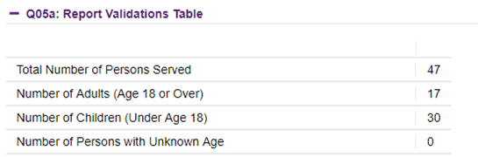

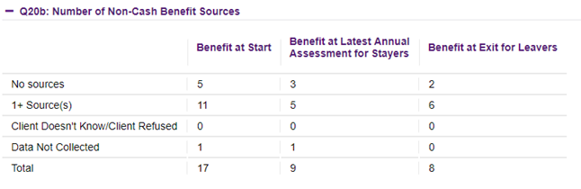

(6) Health Insurance – SAGE APR, Q21: Health Insurance
- This measure includes everyone (adults and children).
- Note the number of total people served in the program from Q05a: Report Validation Table – Total Number of Persons Served.
- Add number of people in row “No Health Insurance,” column “At Annual assessment for Stayers” and column “At exit for leavers” for Answer A.
- Take Total Number of Persons served and subtract the number in row “Number of Stayers Not Yet Required to Have an Annual Assessment” column “At Annual assessment for Stayers” for Answer B.
- Take Answer A and subtract from Answer B to get Answer C.
- Divide Answer C by Answer B.
- In the example below:
- Total Number of Persons served = 47
- 7 + 12 = 19 (Answer A)
- 47 -1 = 46 (Answer B)
- 46-19 = 27 (Answer C)
- 27 divided by 46 = .5869 or 58.7%

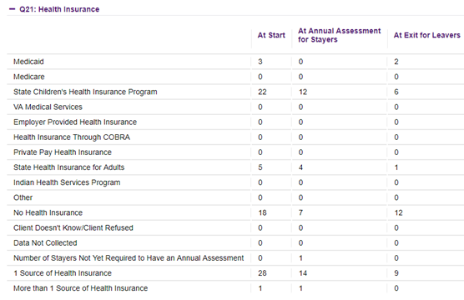

(7) Reoccurrence (SPM) – ICA generated HMIS report
- The SPM (system performance measure) report calculates any successful exit from a CoC-funded housing program into an Emergency Shelter/motel voucher program that uses HMIS within 2 years of an exit.

(8) Reoccurrence (MN Returns report) – ICA generated HMIS report
- The MN Returns report calculates any exit from a CoC-funded housing program into an Emergency Shelter/motel voucher program that uses HMIS within 2 years of an exit.

(9) Coordinated Entry Denials outside CoC approved Eligibility Criteria – CES CoC Denials Report
- The SMAC Coordinated Entry staff will compile a report showing all denials for criteria falling outside of the eligibility criteria approved by the CoC Governing Board from each CoC project.

Part 2b: Program Performance – Rapid Re-Housing (RRH) (32 points possible)
Criteria | 8 points | 4 points | 0 points
- Housing Stability | 75% or higher | 65 - 74% | 64% or less
 | 2 points | 1 point | 0 points
- Increase Earned Income | 30% or higher | 20 - 29% | 19% or less
- Non-Cash Benefits | 90% or higher | 70 – 89% | 69% or less
- Health Insurance | 90% or higher | 70 – 89% | 69% or less
 | 4 points | 2 points | 0 points
- Increase Total Income | 60% or higher | 55 - 59% | 44% or less
- Reoccurrence (SPM) | 0 – 10% | 10.1 – 20% | over 20%
- Reoccurrence (Returns report) | 0 – 10% | 10.1 – 20% | over 20%
- Coordinated Entry Denials | 15% or less | 16-25% | over 25%

Source:
(1) Housing Stability – SAGE APR, Q23a: Exit Destination – More than 90 Days; Q23b: Exit Destination – Less than 90 Days
- Find “Subtotal” for Exits to Permanent Destinations to get Answer A
- Add the number of stayers from Q22a1, column Stayers & row “Total” to Answer A to get answer B.
- Find “Total” in Q23c to get answer C
- Add the number of stayers from Q22a1, column Stayers & row “Total” to Answer C to get Answer D.
- Divide Answer D by Answer B to get the number of exits to permanent destination including stayers.
- In the example below:
- 1 (Answer A)
- 1+11=12 (Answer B)
- 2 (Answer C)
- 11+2=13 (Answer D)
- 12 divided by 13 = .923 or 92.3%

(2) Increase Earned Income – SAGE APR, Q19a3: Client Cash Income Change – Income Source – by Start and Latest Status/Exit
- This measure only looks at the 1st row “Number of Adults with Earned Income.”
- Add the number in 8th column “Performance Measure: Adults Who Gained or Increased Income from Start to Annual Assessment” in Q19a1 to the number in the 8th column in Q19a2 to get Answer A.
- Add number in 7th column “Total Adults” in Q19a1 to number in 7th column in Q19a2 to get Answer B.
- Divide Answer A by Answer B.
- In the example below:
  - 7+5 = 12 (Answer A)
  - 38+21 = 59 (Answer B)
  - 7/59 = 0.118644 or 11.7%
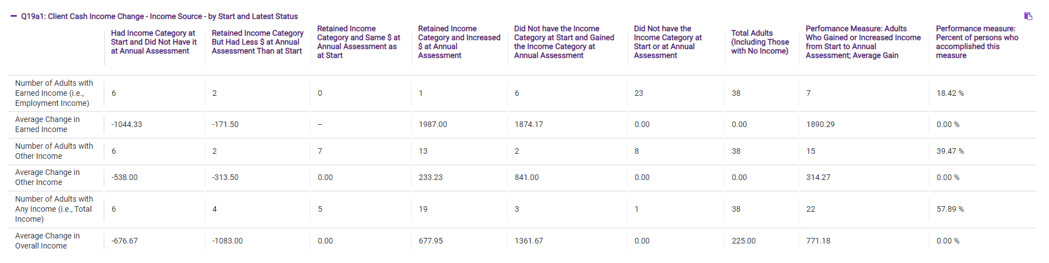
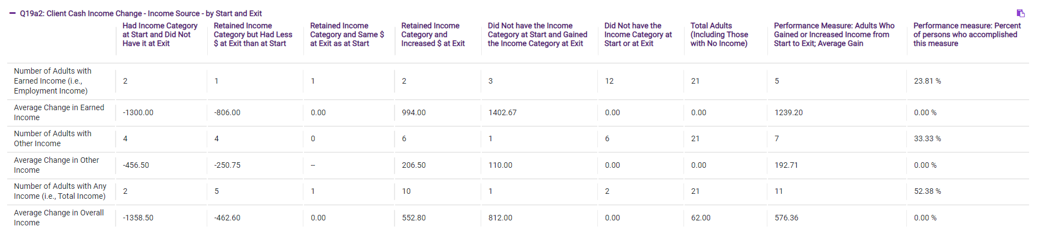

(3) Increase Total Income –SAGE APR, Q19a3: Client Cash Income Change – Income Source – by Start and Latest Status/Exit
- This measure only looks at the 5th row “Number of Adults with Any Income.”
- Add the number in 8th column “Performance Measure: Adults Who Gained or Increased Income from Start to Annual Assessment” in Q19a1 to the number in the 8th column in Q19a2 to get Answer A.
- Add number in 7th column “Total Adults” in Q19a1 to number in 7th column in Q19a2 to get Answer B.
- Divide Answer A by Answer B.
- In the example below:
  - 22+11 = 33 (Answer A)
  - 38+21 = 59 (Answer B)
  - 22/59 = 037288 or 37.3%

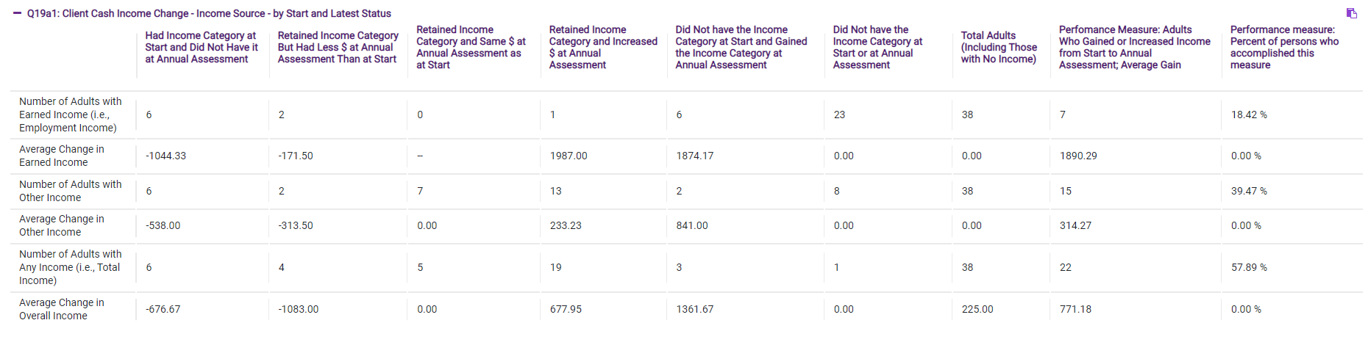
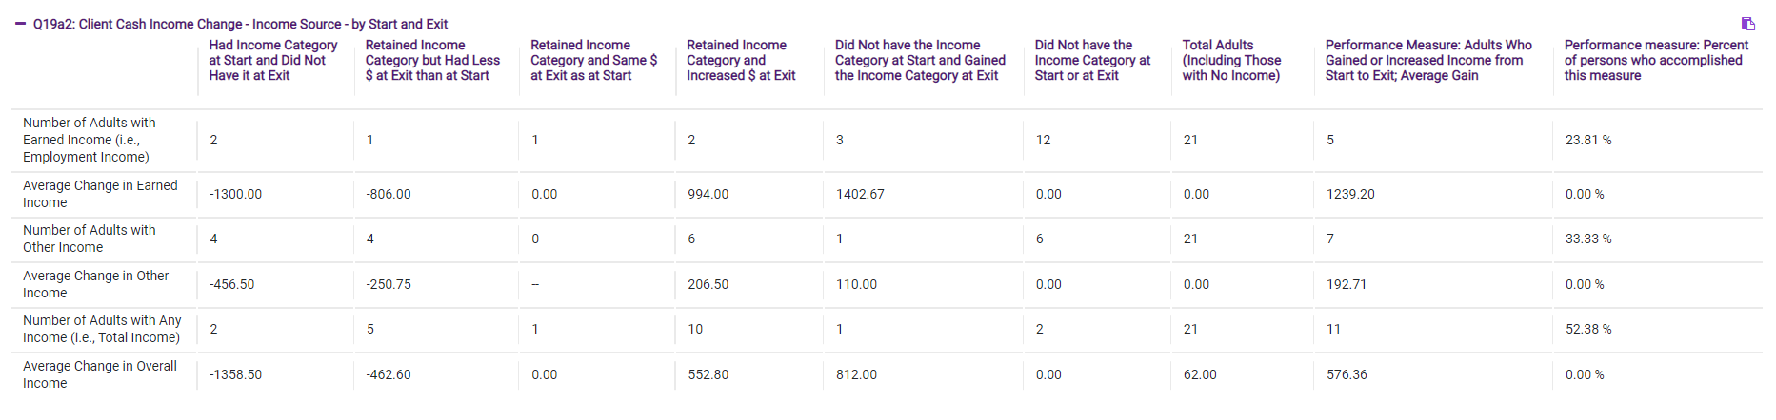

(5) Non-Cash Benefits – SAGE APR, Q20b: Number of Non-Cash Benefit Sources
- This measure only includes adults in households.
- Note the number of adults in the program from Q05a: Report Validation Table - number of adults (age 18 or over).
- Add number of people in row “No Sources,” column “Benefit at latest annual assessment for stayers to column “Benefit at exit for leavers.”
- Subtract from the total number of adults.
- Divide that number by the number of adults.
- In the example below:
- Number of Adults = 17
- Number of No Sources “Benefit at latest annual assessment for stayers” = 3
- Number of No Source “Benefit at exit for leavers” = 2
- 3+2 = 5; 17-5 = 12; 12 divided by 17 = .7058

(6) Health Insurance – SAGE APR, Q21: Health Insurance
- This measure includes everyone (adults and children).
- Note the number of total people served in the program from Q05a: Report Validation Table – Total Number of Persons Served.
- Add number of people in row “No Health Insurance,” column “At Annual assessment for Stayers” and column “At exit for leavers” for Answer A.
- Take Total Number of Persons served and subtract the number in row “Number of Stayers Not Yet Required to Have an Annual Assessment” column “At Annual assessment for Stayers” for Answer B.
- Take Answer A and subtract from Answer B to get Answer C.
- Divide Answer C by Answer B.
- In the example below:
- Total Number of Persons served = 47
- 7 + 12 = 19 (Answer A)
- 47 -1 = 46 (Answer B)
- 46-19 = 27 (Answer C)
- 27 divided by 46 = .5869 or 58.7%

(7) Reoccurrence (SPM) – ICA generated HMIS report
- The SPM (system performance measure) report calculates any successful exit from a CoC-funded housing program into an Emergency Shelter/motel voucher program that uses HMIS within 2 years of an exit.

(8) Reoccurrence (MN Returns report) – ICA generated HMIS report
- The MN Returns report calculates any exit from a CoC-funded housing program into an Emergency Shelter/motel voucher program that uses HMIS within 2 years of an exit.

- Coordinated Entry Denials outside CoC approved Eligibility Criteria – CES CoC Denials Report
- The SMAC Coordinated Entry staff will compile a report showing all denials for criteria falling outside of the eligibility criteria approved by the CoC Governing Board from each CoC project.

Part 3: Program Performance – Racial equity (32 points possible—points shown are for information purposes only)
Criteria | 8 points | 4 points | 0 points
Equity – Board/Leadership Composition | At least 20% of organization's board, directors, managers identify as BIPOC, and/or as LGBTQ+, and /or have experienced homelessness | 10-19% of organization's board, directors, managers identify as BIPOC, and/or as LGBTQ+, and /or have experienced homelessness | Less than 10% of organization's board, directors, managers identify as BIPOC, and/or as LGBTQ+, and /or have experienced homelessness
Equity – Staff Composition | At least 20% of organization's staff identify as Black, Indigenous, or People of Color (BIPOC), and/or as LGBTQ+, and /or have experienced homelessness | 10-19% of organization's staff identify as BIPOC, and/or as LGBTQ+, and /or have experienced homelessness | Less than 10% of organization's staff identify as BIPOC, and/or as LGBTQ+, and /or have experienced homelessness
- Equity—exits to permanent housing | At least 80% of BIPOC participants exited the program to permanent destinations. | 75-80% of BIPOC participants exited the program to permanent destinations. | Less than 75% of BIPOC participants exited the program to permanent destinations.
 | 4 points | 2 points | 0 points
- Equity—increase overall income | 30% or more of BIPOC households increase overall income | 20-29% of BIPOC households increase overall income | Less than 20% of BIPOC households increase overall income
- Equity—returns to homelessness (12 months) | Less than 10% of BIPOC participants returned to homelessness within 12 months of exit to permanent housing | 10-15% of BIPOC participants returned to homelessness within 12 months of exit to permanent housing | 15% or more of BIPOC participants returned to homelessness within 12 months of exit to permanent housing

Renewal Project Applicant Submission Checklist

SUBRECIPIENT NAME:
PROJECT NAME:

Email Items below to Laquita Love-Limo at laquita@mesh-mn.org (PDF format preferred)

Each project must submit the following:

Attached | Due Date | Document | Where to Find Information
☐ | July 31 | LOCCS Draw-Downs and Unspent/Returned Funds. Make sure your data is clean for when ICA pulls your APR. | A print out of your LOCCS screen that shows all of your drawdowns for the grant year
☐ | August 14 | Project Application PDF | Download PDF from https://esnaps.hud.gov/grantium/frontOffice.jsf  DO NOT submit in eSNAPS until a PDF version of your project has been reviewed and approved by the SMAC Coordinator
☐ | August 14 | Organizational Audit or Financial Statement | Your agency files and/or records
☐ | August 14 | Recent HUD Audits and Findings | Your agency files and/or records (if applicable)
☐ | August 14 | Racial Equity Measure Document | Page 26 of this document
☐ | August 14 | Project Educational and Early Childhood Documents (for programs serving families and youth) | Page 27 of this document

Contact person’s name:
Phone:
Email:

2023 SMAC NOFO Policies

Reallocation:
- Voluntary reallocation will always be fully explored first from all renewal projects.
- If voluntary reallocation does not establish enough funding to create a sustainable project, SMAC will consider all projects scoring in the bottom 1/3 eligible to be considered for Reallocation. (It is anticipated that SMAC will have 18 renewal projects in 2021.)
- If the project scores below 65% of the total points available to that project, the project will be considered for reallocation or a mandatory improvement plan.
Additional Considerations:
  - Historical scoring data- The Monitoring and Evaluation Committee will review if the project has scored in the bottom 1/3 past 3 NOFA competitions.
  - Cost Effectiveness of project- The total HUD grant award amount will be divided by the number of successful outcomes. Successful outcome for all projects (other than PSH) is exiting to permanent housing. Successful outcome for PSH includes exits to permanent housing and remaining in permanent housing.
  - Coordinated Entry data- The Ranking Committee will review Coordinated Entry data and other priority setting data used by the Governing Board to ensure needs and gaps are being met across the geography of the CoC.

Example
A non-PSH project gets $100,000 grant. 25 households successfully went to permanent housing. The cost per successful outcome is: $4,000.

A PSH project gets $100,000 grant. 5 households successfully went to permanent housing. 4 households remain in permanent housing. The cost per successful outcome is: $11,111.

The Monitoring and Evaluation Committee will make the final decision regarding which projects will be recommended to the Governing Board for Reallocation. For the 2021 competition the Ranking Committee should consider offering Technical Assistance to the bottom 1/3 of projects as an alternative to Reallocation due to recent implementation of the current scoring tool and reallocation approach.

Ranking:

- HMIS grant will automatically be placed just above the SSO-CE grant(s) at the bottom of Tier 1. SMAC highly values having a functional HMIS. SMAC feels that it is essential to fund HMIS adequately and feels strongly that HMIS funds need to be protected in Tier 1.

- SSO-CE grants will be placed just above any New project(s) created through reallocation at the bottom of Tier 1. To have a high quality, effective CES funding needs to be allocated to support infrastructure for CES activities. HUD has not provided guidance for how to score and evaluate these projects but encourages CoCs to maintain funding for these grants. Therefore, SMAC feels SSO-CE grants should be protected in Tier 1.

- New projects created through reallocation will be ranked just above the new BONUS project(s) at the bottom of Tier 1. New projects will all be scored through the RFP process and evaluated on the New Project Application score tool. If a new project is selected through the RFP process it demonstrates the project will fill a gap in the CoC and will be prioritized as such through Tier 1 ranking.

The bottom of Tier 1 will look as follows:
- HMIS Project
- Coordinated Entry Project
- New project(s)/Expansion project(s) created through reallocation

- The Ranking Committee will make a decision on Tier 1 Ranking for any BONUS project based on need and strength of the BONUS application.

Scoring:
- Once the total number of points are calculated, the number of points earned will be divided by the total possible points for that project type. The resulting percentage will be placed in descending order, highest at top and lowest at bottom. If there is a tie between projects, a tiebreaker score will be used.

- The tiebreaker score will be based on cost effectiveness. The total HUD grant award amount will be divided by the number of successful outcomes. Successful outcome for all projects (other than PSH) is exiting to permanent housing. Successful outcome for PSH includes exits to permanent housing and remaining in permanent housing.

Example
A non-PSH project gets $100,000 grant. 25 households successfully went to permanent housing. The cost per successful outcome is: $4,000.

A PSH project gets $100,000 grant. 5 households successfully went to permanent housing. 4 households remain in permanent housing. The cost per successful outcome is: $11,111.

- Rounding for all scoring will be standard rounding to the second decimal point.

- Renewal Projects will be penalized for late application submission to the CoC. Projects will lose 8 points for submitting a late application. Timelines are critical during the NOFO process and it is essential that projects get all documents to the CoC on time.

- New projects awarded in the last competition that have not yet begun and those projects that have not finished their first year or have not submitted their first APR but must submit a renewal application will be placed at the bottom of Tier 1 and exempt from the scoring process.

- Projects that have completed only their first APR will be exempt from the following scoring categories: 1) Use of Federal Funds, 2) Unit Utilization, 3) Exits to Permanent Housing, 4) All income measures, 5) Reoccurance, 6) Mainstream Benefits, 7) Health Insurance. SMAC does not want to penalize projects that are new to CoC funding and have not had the opportunity to score well in these areas.

- If an agency was not able to access eLOCCS during the course of the year through no fault of their own, the agency is responsible for notifying the CoC and providing confirmation from the HUD Field Office. If so, the agency would be exempt from the scoring criteria.

Racial Equity Measures
SMAC is committed to evaluating our processes through a racial equity lens. We seek to understand our program landscape so that we know where we are starting from, and where we can improve. These questions will be scored in the 2023 NOFO.
- Please list the percentage (please show your work) of board/directors/managers that identify as BIPOC, and/or as LGBTQ+, and/or have experienced homelessness. (8 points)

- Please list the percentage (please show your work) of division/program staff that identify as BIPOC, and/or as LGBTQ+, and/or have experienced homelessness. (8 points)

Education and Early Childhood Policy
All homeless assistance projects within the SMAC region that serve households with children (shelter, transitional housing, rapid re-housing, and permanent supportive housing) will be expected to comply with the following policies:

Identify staff who have primary responsibility for school attendance.

Ensure that all homeless families are informed of the McKinney Vento Act to ensure that their children are able to maintain enrollment in school.

Advocate for families with their school district to ensure that transportation is arranged (as needed).

Track school attendance for all children served within your program and help families to resolve any barriers that are contributing to the absences (as needed).

Assist families in developing education related goals for all family members when completing Housing Goal Plans.

Ensure that all family members are connected to relevant educational resources in the community.

Encourage and assist families with children ages 3-5 to apply for the Head Start Program and provide referrals to agencies that offer Head Start.

My agency serves families and/or youth and receives CoC program funding. I certify that we follow the above SMAC policy regarding Education and Early Childhood.

______________________________________________ ______________________
Agency Signature Date

